Name

Mathematics Extension 1 Year 12
Volumes of Rotation

Book 1 |  | Version: 261020  Feedback:  https://MrDingMaths.com
Contents
Syllabus Content 2
Learning Intention 3

Syllabus Content
ME1-12-05 applies calculus to solve problems involving polynomials, further rates of change, areas and volumes and differential equations
Areas between curves and volumes of solids of revolution
- Calculate areas of regions between curves determined by functions in both real-life and abstract contexts
- Examine a solid of revolution whose boundary is formed by rotating an arc of a function about the $x$-axis or $y$-axis with and without graphing applications
- Calculate the volume of a solid of revolution formed by rotating a region in the plane about the $x$-axis or $y$-axis in both real-life and abstract contexts
- Calculate the volume of a solid of revolution formed by rotating the region between two curves about either the $x$-axis or $y$-axis in both real-life and abstract contexts

Area Between Two Curves

- Review
- Find point of intersection of two curves and sketch both curves on the same axes.
- $y=x^{2}$ and $y=x+2$ | - $y=x^{2}$ and $y=x+6$
- $y=x^{3}$ and $y=4x$ | - $y={\left(x-1\right)}^{2}$ and $y={\left(x+1\right)}^{2}$
- $y=x$ and $y=2{\left(x-3\right)}^{2}$ | - $y=x{\left(x-4\right)}^{2}$ and $y=x$

- Area Under a Combination of Curves
Sometimes a region is bounded by different curves in different sections along the $x$-axis. Because no single curve forms the top boundary across the whole region, you must split the region at the point(s) of intersection and calculate each section separately.
- Find the intersection points.
- Set up separate definite integrals for each section.
- Integrate and add the results.

- Example Find area under a combination of curves
Find the area bounded by $y=x^{2}$, $y={\left(x-4\right)}^{2}$ and the axis.
1. Intersection points  $$x^{2}={\left(x-4\right)}^{2}$$  $x^{2}=x^{2}-8x+16$  $x=2$  2. Set up integrals  $$\int_{0}^{2}{x^{2}}dx+\int_{2}^{4}{{\left(x-4\right)}^{2}}dx$$ | 3. Integrate and add  $$={\left[\frac{x^{3}}{3}\right]}_{0}^{2}+{\left[\frac{{\left(x-4\right)}^{3}}{3}\right]}_{2}^{4}$$  $$=\left(\frac{8}{3}-0\right)+\left(0-\frac{-8}{3}\right)$$  $$=\frac{16}{3} u^{2}$$ | 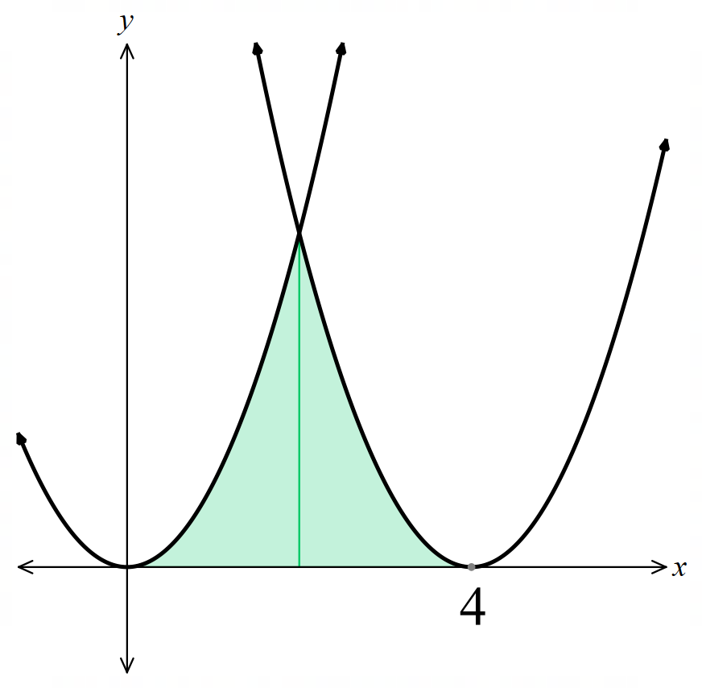

- Guided Practice
- Find the area of the bounded by $y=x,$ $y =2(x-3)²,$ and the $x$-axis.
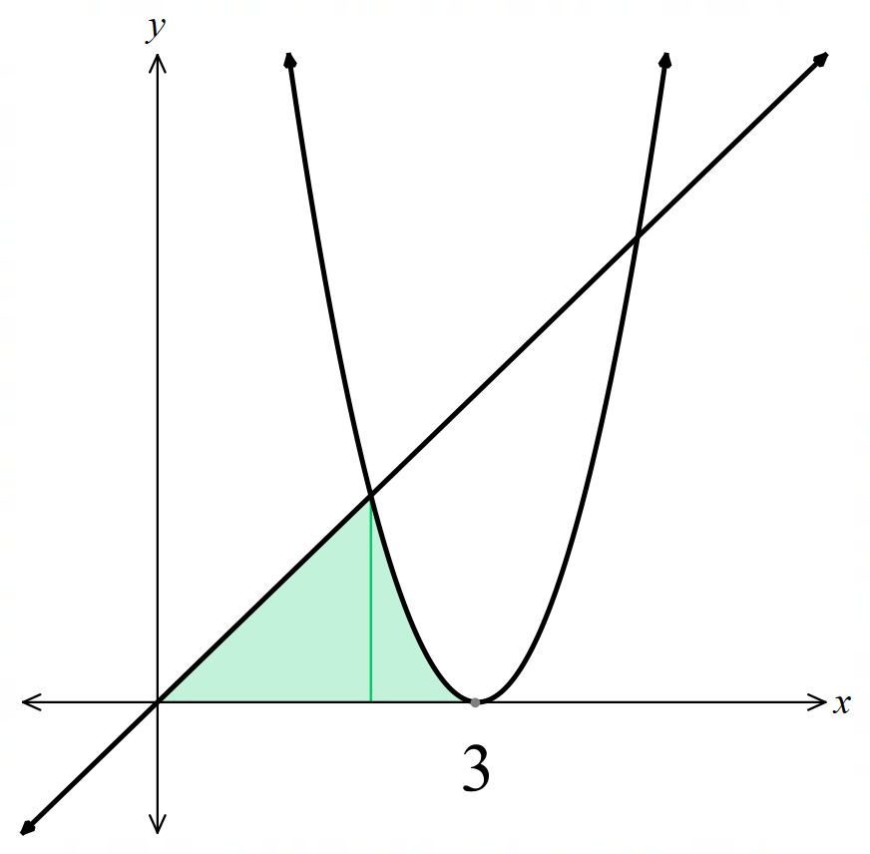

$$\frac{8}{3}$$
- Find the area of the bounded by $y = 4x²,$ $y = (x+3)²,$ and the $x$-axis.
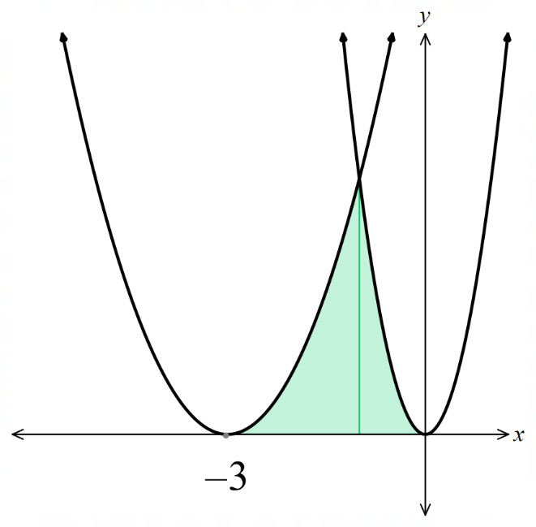

4
- Area Between Two Curves
When two curves intersect at two points, they enclose a region between them.
To find this area, integrate the difference between the upper curve and the lower curve.
- Find the intersection points.
- Identify the upper curve; the one with the larger $y$-values is the upper curve.
A sketch is useful, you can also substitute $x$ values into each function to check.
- Set up the integral as $∫\left(upper curve-lower curve\right) dx$.
If the curves cross each other in the domain, split the region into subintervals.
Simplify the integrand if possible.
- Integrate and evaluate.

- Example Find area between two curves
Find the area enclosed between $y=x^{2}$and $y=x+2$.
1. Intersection points  $$x^{2}=x+2$$  $x^{2}-x-2=0$  $\left(x-2\right)\left(x+1\right)=0$  $$x=-1,2$$  2. Identify upper curve  In the required region,  $y=x+2$ is the upper curve | 3. Set up integral  $$\int_{-1}^{2}{\left(\left(x+2\right)-\left(x^{2}\right)\right)}dx$$  $$=\int_{-1}^{2}{(x+2-x^{2})}dx$$  4. Integrate  $$={\left[\frac{x^{2}}{2}+2x-\frac{x^{3}}{3}\right]}_{-1}^{2}$$  $$=\frac{10}{3}-\left(-\frac{7}{6}\right)$$  $$=4.5 u^{2}$$ | 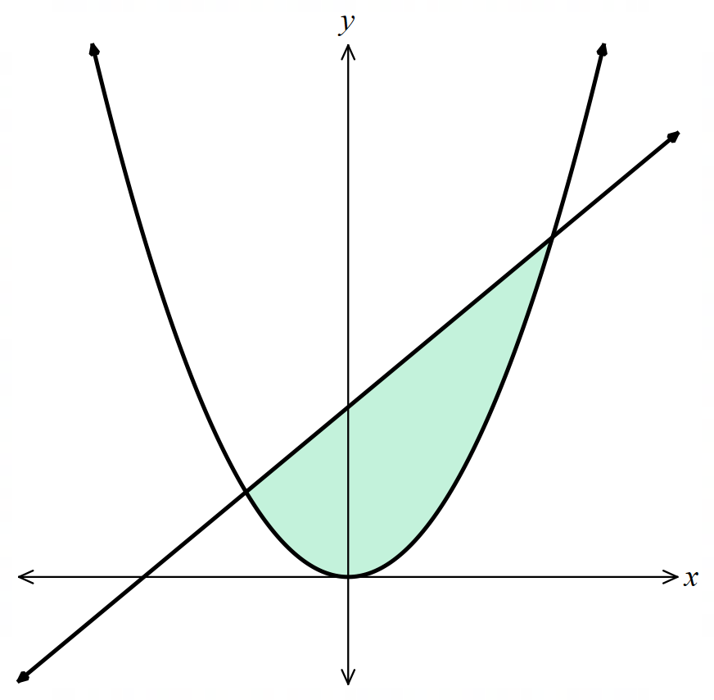

- Guided Practice
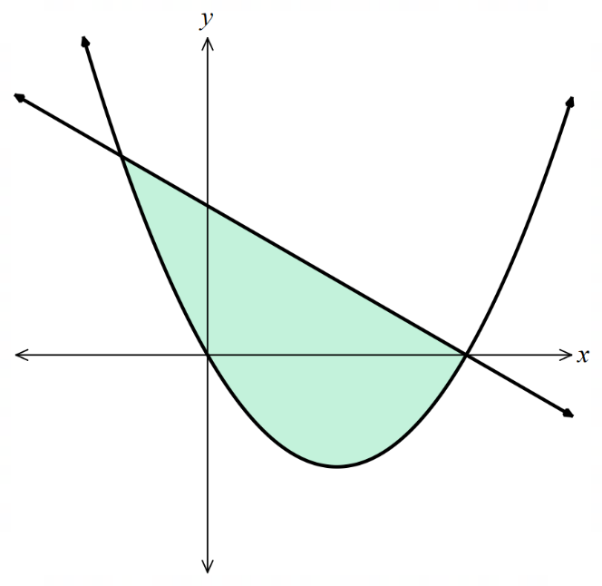
- Find the area enclosed between $y=3-x$ and $y=x²-3x.$

$$\frac{32}{3} u^{2}$$
- Guided Practice
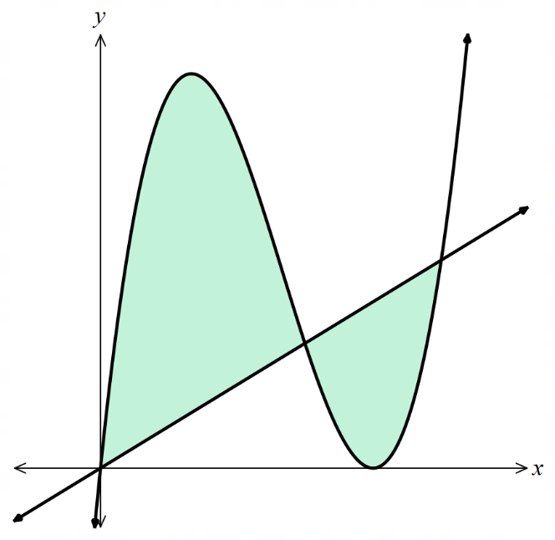
- Find the area bounded between $y=x{\left(x-4\right)}^{2}$ and $y=x$

$$\frac{253}{12} u^{2}$$
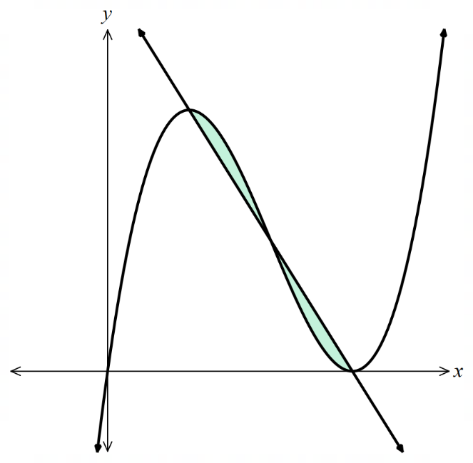
- Find the area bounded between $y=6-2x$ and $y=x{\left(x-3\right)}^{2}$

$$\frac{1}{2} u^{2}$$

Foundation
- Find the area of the shaded region in each diagram below:
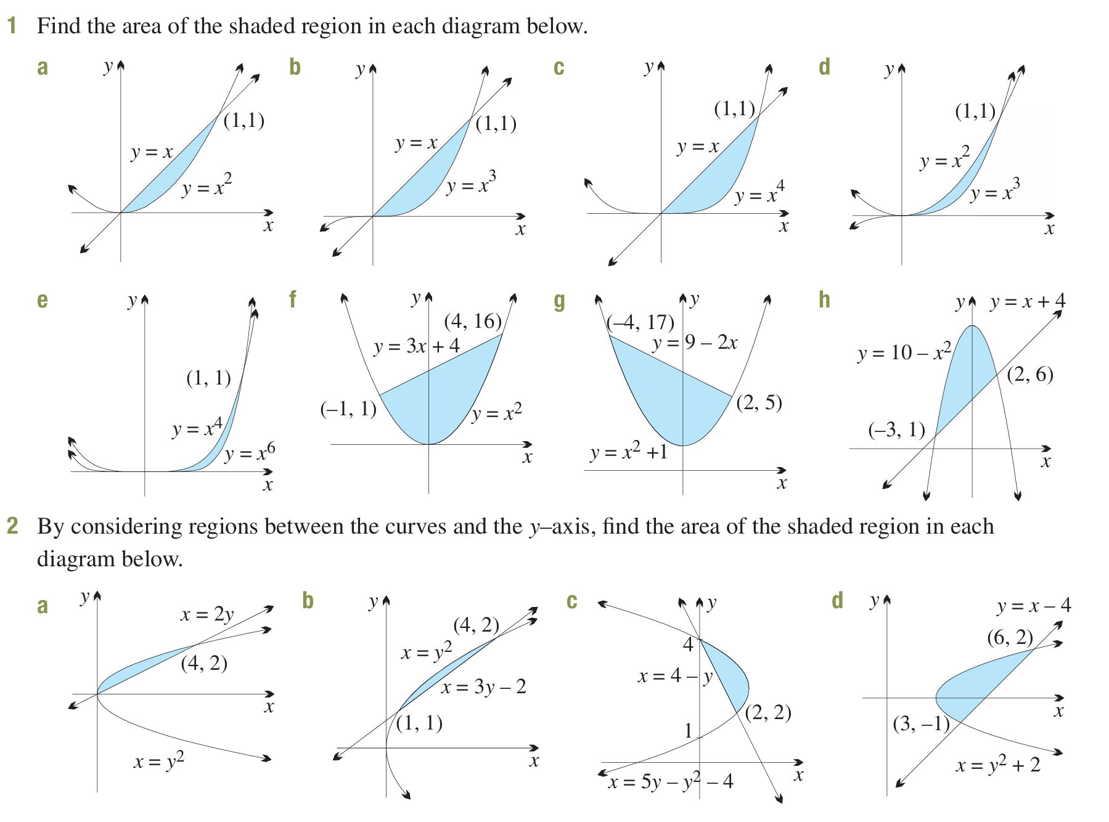  $$A = \int_{0}^{1}{\left(x - x^{2}\right)}dx$$  $$=\frac{1}{6} u^{2}$$ | $$A = \int_{0}^{1}{\left(x - x^{3}\right)}dx$$  $$=\frac{1}{4} u^{2}$$ | $$A = \int_{0}^{1}{\left(x - x^{4}\right)}dx$$  $$=\frac{3}{10} u^{2}$$
$$A = \int_{0}^{1}{\left(x^{2}- x^{3}\right)}dx$$  $$=\frac{1}{12} u^{2}$$ | $$A = \int_{0}^{1}{\left(x^{4}- x^{6}\right)}dx$$  $$=\frac{2}{35} u^{2}$$ | $$A = \int_{-1}^{4}{\left(3x + 4 - x^{2}\right)}dx$$  $$=\frac{125}{6} u^{2}$$
$$A = \int_{-4}^{2}{\left(9 - 2x - x^{2}- 1\right)}dx$$  $$= \int_{-4}^{2}{\left(8 - 2x - x^{2}\right)}dx$$  $$= 36 u^{2}$$ | $$A = \int_{-3}^{2}{\left(10 - x^{2}- x - 4\right)}dx$$  $$= \int_{-3}^{2}{\left(6 - x - x^{2}\right)}dx$$  $$=\frac{125}{6} u^{2}$$
- By considering regions between the curves and the $y$-axis, find the area of the shaded region.
$$A = \int_{0}^{2}{\left(2y - y^{2}\right)}dy$$  $$=\frac{4}{3} u^{2}$$ | $$A = \int_{1}^{2}{\left(3y - 2 - y^{2}\right)}dy$$  $$=\frac{1}{6} u^{2}$$
$$A = \int_{2}^{4}{\left(5y-y^{2}-4-4+y\right)}dy$$  $$= \int_{2}^{4}{\left(6y-y^{2}-8\right)}dy$$  $$=\frac{4}{3} u^{2}$$ | $$A = \int_{-1}^{2}{\left(y + 4 - y^{2}- 2\right)}dy$$  $$= \int_{-1}^{2}{\left(y + 2 - y^{2}\right)}dy$$  $$=\frac{9}{2} u^{2}$$

- Find the areas of the shaded regions. You will need to find two areas and add.
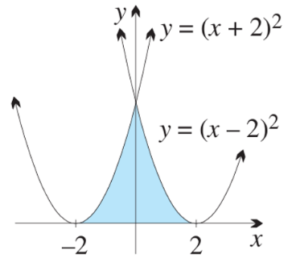  $$\int_{-2}^{0}{{\left(x-2\right)}^{2}}dx+\int_{0}^{2}{{\left(x+2\right)}^{2}}dx$$  $$5\frac{1}{3} u^{2}$$ | 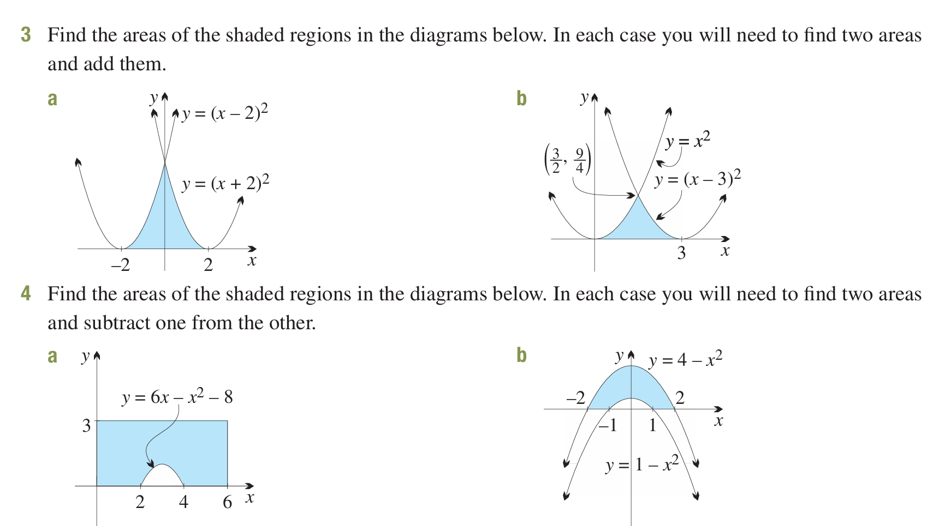  $$\int_{0}^{\frac{3}{2}}{x^{2}}dx+\int_{\frac{3}{2}}^{3}{{\left(x-3\right)}^{2}}dx$$  $$\frac{9}{4} u^{2}$$

- Find the areas of the shaded regions. You will need to find two areas and subtract.
$$3\left(6\right)-\int_{2}^{4}{6x-x^{2}-8}dx$$  $$=16\frac{2}{3} u^{2}$$ | $$\int_{-2}^{2}{4-x^{2}}dx-\int_{-1}^{1}{1-x^{2}}dx$$  $$=9\frac{1}{3} u^{2}$$

  - Show that $y = x² + 4$ and $y = x + 6$ intersect at $(-1, 5)$ and $(2, 8)$.
  - Sketch the parabola and line, shading the enclosed region.
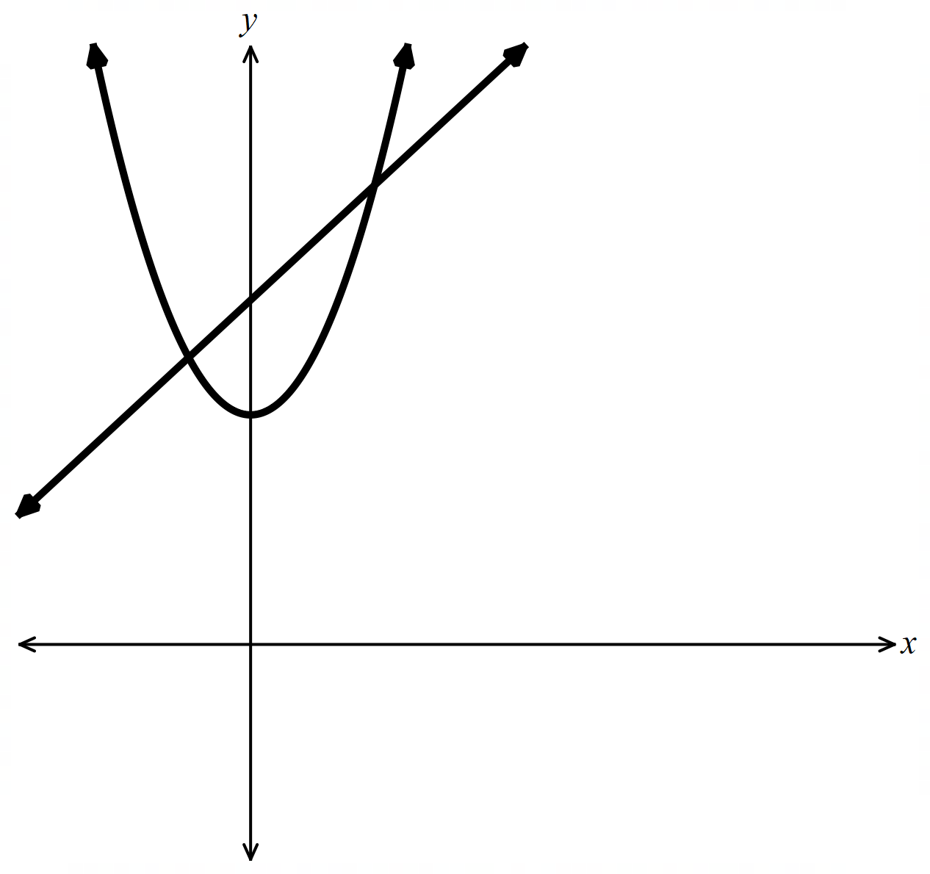
  - Show that $\int_{-1}^{2}{\left(\left(x + 6\right)- \left(x^{2}+ 4\right)\right)}dx = \int_{-1}^{2}{\left(x - x^{2}+ 2\right)}dx$, and evaluate.
$$x^{2}+ 4 = x + 6$$
$$x^{2}- x - 2 = 0$$
$$\left(x - 2\right)\left(x + 1\right)= 0$$
$$x = 2 or x = -1$$
$$x = 2: y = 2 + 6 = 8 → \left(2, 8\right)$$
$$x = -1: y = -1 + 6 = 5 → \left(-1, 5\right)$$
$$\int_{-1}^{2}{\left(\left(x + 6\right)- \left(x^{2}+ 4\right)\right)}dx = \int_{-1}^{2}{\left(x - x^{2}+ 2\right)}dx$$
$$= {\left[\frac{x^{2}}{2}-\frac{x^{3}}{3}+ 2x\right]}_{-1}^{2}$$
$$=\frac{9}{2} u^{2}$$

  - Show that $y = 3x - x² = x\left(3 - x\right)$ and $y = x$ intersect at $(0, 0)$ and $(2, 2).$
  - Sketch the parabola and line, shading the enclosed region.
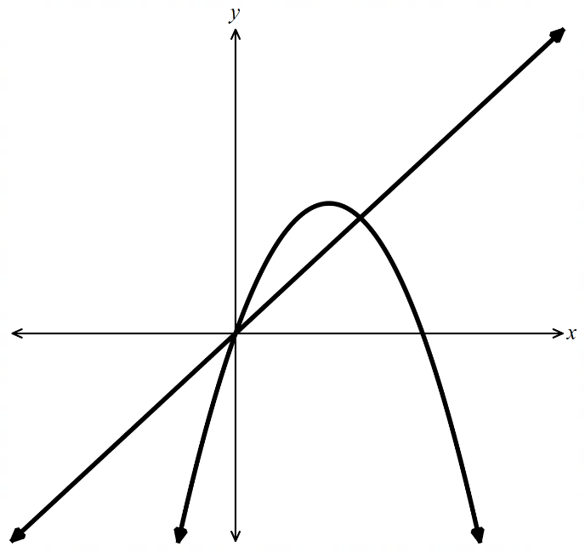
  - Show that$\int_{0}^{2}{\left(3x - x^{2}- x\right)}dx = \int_{0}^{2}{\left(2x - x^{2}\right)}dx$, and evaluate.
$$3x - x^{2}= x$$
$$2x - x^{2}= 0$$
$$x\left(2 - x\right)= 0$$
$$x = 0 or x = 2$$
$$x = 0: y = 0 → \left(0, 0\right)$$
$$x = 2: y = 2 → \left(2, 2\right)$$
$$\int_{0}^{2}{\left(3x - x^{2}- x\right)}dx = \int_{0}^{2}{\left(2x - x^{2}\right)}dx$$
$$= {\left[x^{2}-\frac{x^{3}}{3}\right]}_{0}^{2}$$
$$=\frac{4}{3} u^{2}$$

Development

  - Show that $y = {\left(x - 3\right)}^{2}$ and $y = 14 - 2x$ intersect at $(-1, 16)$ and $(5, 4).$
  - Sketch the parabola and line, shading the enclosed region.
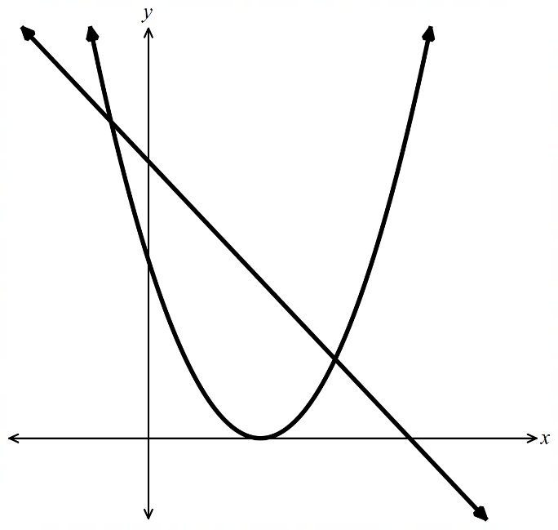
  - Show that $\int_{-1}^{5}{\left(\left(14 - 2x\right)- {\left(x - 3\right)}^{2}\right)}dx = \int_{-1}^{5}{\left(4x + 5 - x^{2}\right)}dx$, and evaluate.
$${\left(x - 3\right)}^{2}= 14 - 2x$$
$$x^{2}- 6x + 9 = 14 - 2x$$
$$x^{2}- 4x - 5 = 0$$
$$\left(x - 5\right)\left(x + 1\right)= 0$$
$$x = 5 or x = -1$$
$$x = 5: y = 14 - 10 = 4 → \left(5, 4\right)$$
$$x = -1: y = 14 + 2 = 16 → \left(-1, 16\right)$$

$$(14 - 2x) - (x - 3)² = 4x + 5 - x²$$
$$\int_{-1}^{5}{\left(4x + 5 - x^{2}\right)}dx = {\left[2x^{2}+ 5x -\frac{x^{3}}{3}\right]}_{-1}^{5}$$
$$= \left(50 + 25 -\frac{125}{3}\right)- \left(2 - 5 +\frac{1}{3}\right)$$
$$= 36 u^{2}$$
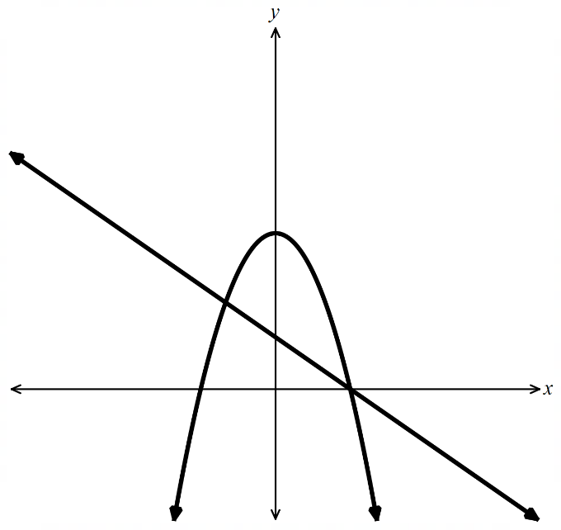
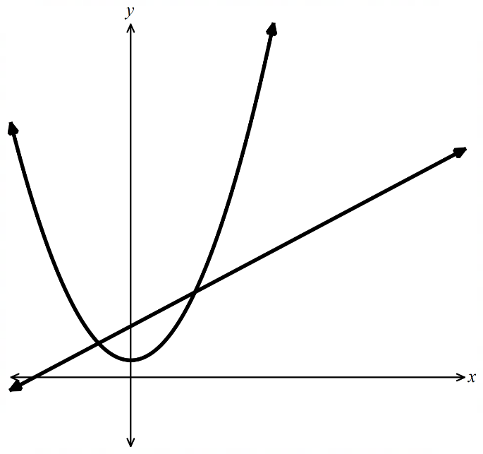
- Solve simultaneously, sketch, shade the enclosed region, and find its area for:
  - $y=x+3$and$y=x²+1$
$$x + 3 = x^{2}+ 1$$
$$x^{2}- x - 2 = 0$$
$$\left(x - 2\right)\left(x + 1\right)= 0$$
$$x = 2 or x = -1$$
$$Intersections: (2, 5) and (-1, 2)$$
$$Line is above parabola on [-1, 2].$$
$$\int_{-1}^{2}{\left(\left(x + 3\right)- \left(x^{2}+ 1\right)\right)}dx = \int_{-1}^{2}{\left(x - x^{2}+ 2\right)}dx$$
$$= {\left[\frac{x^{2}}{2}-\frac{x^{3}}{3}+ 2x\right]}_{-1}^{2}$$
$$= \left(2 -\frac{8}{3}+ 4\right)- \left(\frac{1}{2}+\frac{1}{3}- 2\right)$$
$$=\frac{9}{2} u^{2}$$
  - $y=9-x²$and$y=3-x$

$$9 - x^{2}= 3 - x$$
$$x^{2}- x - 6 = 0$$
$$\left(x - 3\right)\left(x + 2\right)= 0$$
$$x = 3 or x = -2$$
$$Intersections: (3, 0) and (-2, 5)$$
$$Parabola is above line on [-2, 3].$$
$$\int_{-2}^{3}{\left(\left(9 - x^{2}\right)- \left(3 - x\right)\right)}dx = \int_{-2}^{3}{\left(6 + x - x^{2}\right)}dx$$
$$= {\left[6x +\frac{x^{2}}{2}-\frac{x^{3}}{3}\right]}_{-2}^{3}$$
$$= \left(18 +\frac{9}{2}- 9\right)- \left(-12 + 2 +\frac{8}{3}\right)=\frac{125}{6} u^{2}$$
  - $y=x²-x+4$and$y=-x²+3x+4$
$$x^{2}- x + 4 = -x^{2}+ 3x + 4$$
$$2x^{2}- 4x = 0$$
$$2x\left(x - 2\right)= 0$$
$$x = 0 or x = 2$$
$$Intersections: (0, 4) and (2, 6)$$
$$Second parabola is above first on \left[0, 2\right].$$
$$\int_{0}^{2}{\left(\left(-x^{2}+ 3x + 4\right)- \left(x^{2}- x + 4\right)\right)}dx = \int_{0}^{2}{\left(4x - 2x^{2}\right)}dx$$
$$= {\left[2x^{2}-\frac{2x^{3}}{3}\right]}_{0}^{2}$$
$$= 8 -\frac{16}{3}=\frac{8}{3} u^{2}$$
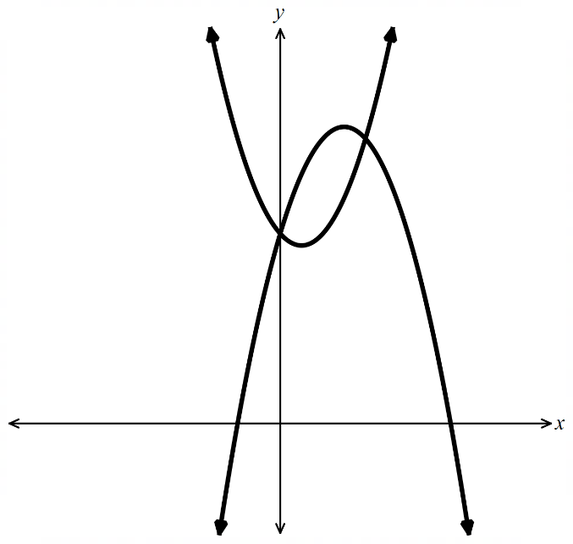
  - Show that $y = x^{2}+ 2x - 8$ and $y = 2x + 1$ intersect at $(3, 7)$ and $(-3, -5).$
  - Sketch both graphs, shading the enclosed region.
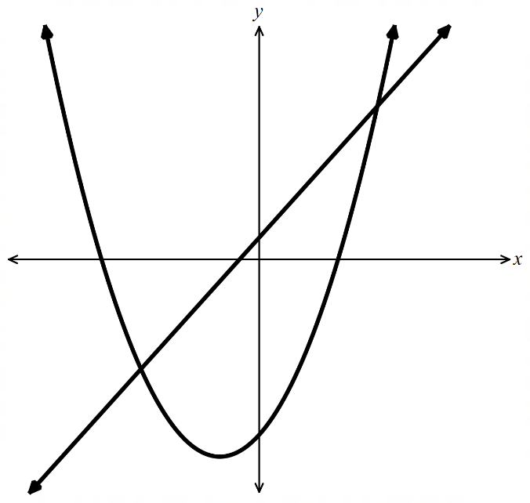
  - Show that $\int_{-3}^{3}{\left(\left(2x + 1\right)- \left(x^{2}+ 2x - 8\right)\right)}dx = \int_{-3}^{3}{\left(9 - x^{2}\right)}dx$.
Evaluate and find the area.
$$x^{2}+ 2x - 8 = 2x + 1$$
$$x^{2}- 9 = 0$$
$$\left(x - 3\right)\left(x + 3\right)= 0$$
$$x = 3 or x = -3$$
$$x = 3: y = 7 → \left(3, 7\right)$$
$$x = -3: y = -5 → \left(-3, -5\right)$$
$$(2x + 1) - (x² + 2x - 8) = 9 - x²$$
$$\int_{-3}^{3}{\left(9 - x^{2}\right)}dx = {\left[9x -\frac{x^{3}}{3}\right]}_{-3}^{3}$$
$$= \left(27 - 9\right)- \left(-27 + 9\right)$$
$$= 36 u^{2}$$

  - Show that $y = x² - x - 2$ and $y = x - 2$ intersect at $(0, -2)$ and $(2, 0).$
  - Sketch both graphs, shading the enclosed region.
  - Show that $\int_{0}^{2}{\left(\left(x - 2\right)- \left(x^{2}- x - 2\right)\right)}dx = \int_{0}^{2}{\left(2x - x^{2}\right)}dx$. Evaluate and find the area.
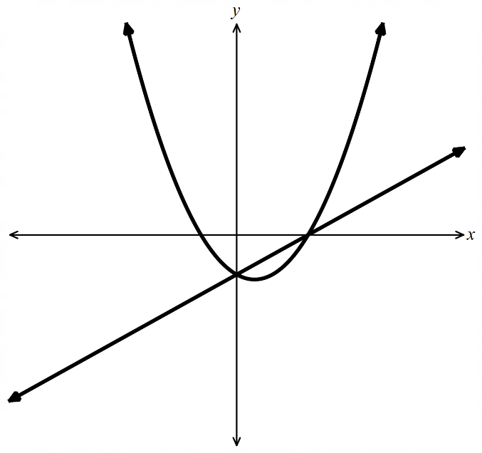
$$x^{2}- x - 2 = x - 2$$
$$x^{2}- 2x = 0$$
$$x\left(x - 2\right)= 0$$
$$x = 0 or x = 2$$
$$x = 0: y = -2 → \left(0, -2\right)$$
$$x = 2: y = 0 → \left(2, 0\right)$$

$$(x - 2) - (x² - x - 2) = 2x - x²$$
$$\int_{0}^{2}{\left(2x - x^{2}\right)}dx = {\left[x^{2}-\frac{x^{3}}{3}\right]}_{0}^{2}$$
$$= 4 -\frac{8}{3}$$
$$=\frac{4}{3}u^{2}$$
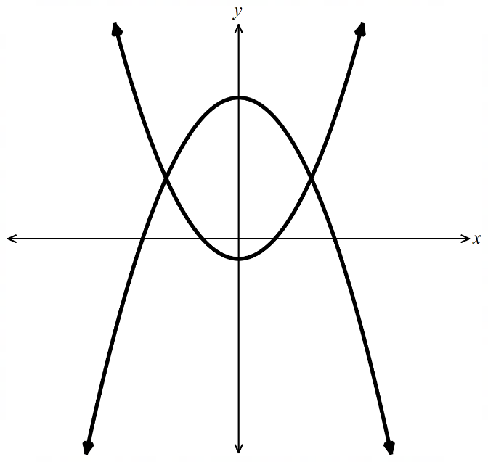
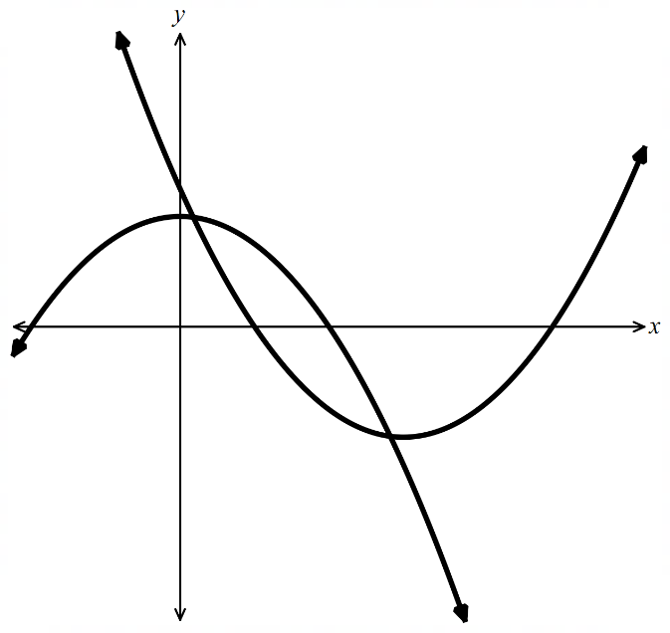
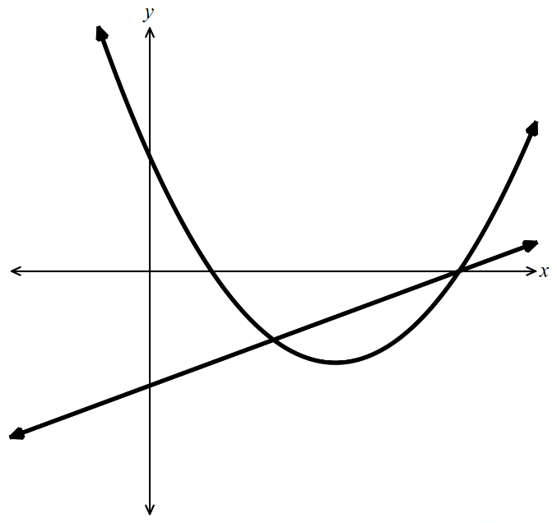
- Solve simultaneously, sketch, shade the enclosed region, and find its area for:
  - $y = x² - 6x + 5$and$y = x - 5$
$$x^{2}- 6x + 5 = x - 5$$
$$x^{2}- 7x + 10 = 0$$
$$\left(x - 2\right)\left(x - 5\right)= 0$$
$$x = 2 or x = 5$$
$$Intersections: (2, -3) and (5, 0)$$
$$Line is above parabola on [2, 5].$$
$$\int_{2}^{5}{\left(\left(x - 5\right)- \left(x^{2}- 6x + 5\right)\right)}dx = \int_{2}^{5}{\left(7x - 10 - x^{2}\right)}dx$$
$$= {\left[\frac{7x^{2}}{2}- 10x -\frac{x^{3}}{3}\right]}_{2}^{5}$$
$$= \left(\frac{175}{2}- 50 -\frac{125}{3}\right)- \left(14 - 20 -\frac{8}{3}\right)$$
$$=\frac{25}{6}- \left(-\frac{26}{3}\right)$$
$$=\frac{9}{2} u^{2}$$
  - $y = -3x$and$y = 4 - x²$
$$-3x = 4 - x^{2}$$
$$x^{2}- 3x - 4 = 0$$
$$\left(x - 4\right)\left(x + 1\right)= 0$$
$$x = 4 or x = -1$$
$$Intersections: (4, -12) and (-1, 3)$$
$$Parabola is above line on \left[-1, 4\right].$$
$$\int_{-1}^{4}{\left(\left(4 - x^{2}\right)- \left(-3x\right)\right)}dx = \int_{-1}^{4}{\left(4 + 3x - x^{2}\right)}dx$$
$$= {\left[4x +\frac{3x^{2}}{2}-\frac{x^{3}}{3}\right]}_{-1}^{4}$$
$$= \left(16 + 24 -\frac{64}{3}\right)- \left(-4 +\frac{3}{2}+\frac{1}{3}\right)$$
$$=\frac{56}{3}- \left(-\frac{13}{6}\right)$$
$$=\frac{125}{6}u^{2}$$
  - $y = x² - 1$and$y = 7 - x²$
$$x² - 1 = 7 - x^{2}$$
$$2x^{2}= 8$$
$$x^{2}= 4$$
$$x = 2 or x = -2$$
$$Intersections: (2, 3) and (-2, 3)$$
$$Second curve is above first on \left[-2, 2\right].$$
$$\int_{-2}^{2}{\left(\left(7 - x^{2}\right)- \left(x^{2}- 1\right)\right)}dx = \int_{-2}^{2}{\left(8 - 2x^{2}\right)}dx$$
$$= {\left[8x -\frac{2x^{3}}{3}\right]}_{-2}^{2}$$
$$= \left(16 -\frac{16}{3}\right)- \left(-16 +\frac{16}{3}\right)$$
$$=\frac{32}{3}+\frac{32}{3}$$
$$=\frac{64}{3}u^{2}$$

Mastery
- Tangents are drawn to $x² = 8y$ at $A(4, 2)$ and $B(-4, 2).$
  - Draw a diagram noting symmetry about the y-axis.
  - Find the equation of the tangent at A.
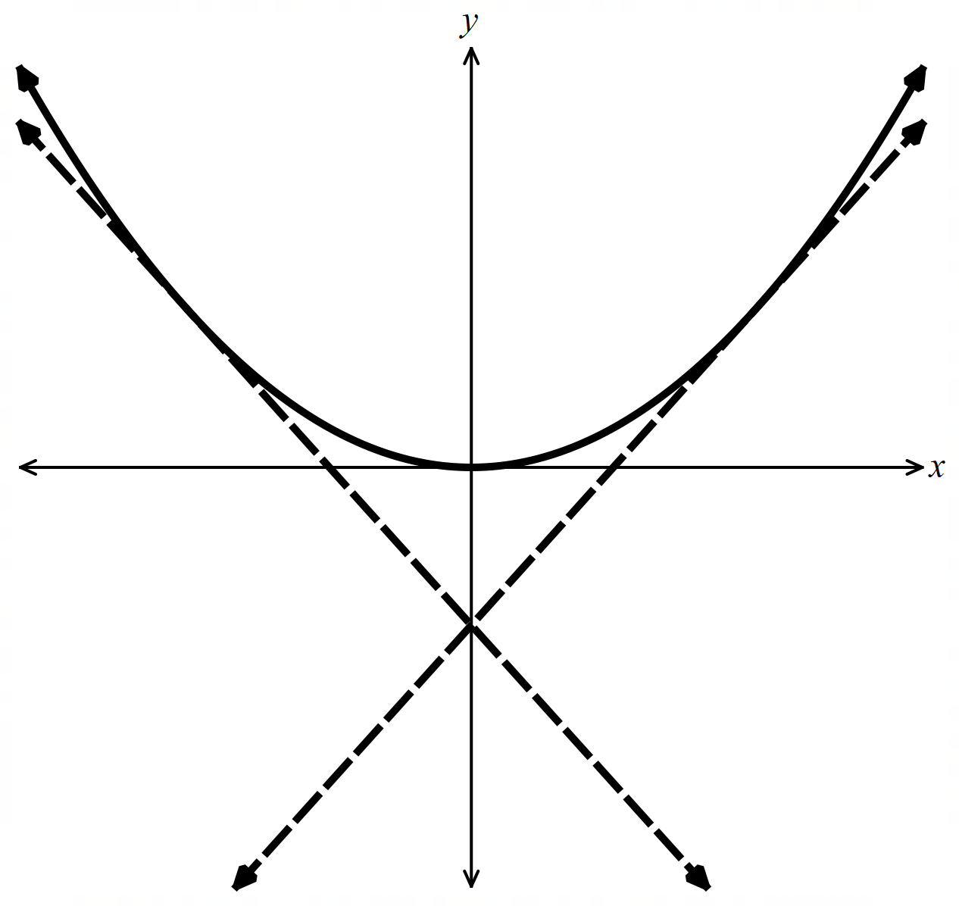
  - Find the area bounded by the curve and the tangents.
$$x^{2}= 8y → y =\frac{x^{2}}{8}$$
$$y^{'}=\frac{x}{4}$$
$$At A\left(4, 2\right): m =\frac{4}{4}= 1$$
$$y - 2 = 1\left(x - 4\right)$$
$$y = x - 2$$
By symmetry, tangent at B:$y = -x - 2$
Tangents meet where$x - 2 = -x - 2,$so$x = 0, y = -2.$
Tangents meet at$(0, -2).$

By symmetry, area $= 2 ×$area from$x = 0$to$x = 4$between curve and tangent at$A.$
$$Area = 2\int_{0}^{4}{\left(\frac{x^{2}}{8}- \left(x - 2\right)\right)}dx = 2\int_{0}^{4}{\left(\frac{x^{2}}{8}- x + 2\right)}dx$$
$$= 2{\left[\frac{x^{3}}{24}-\frac{x^{2}}{2}+ 2x\right]}_{0}^{4}$$
$$= 2\left(\frac{64}{24}- 8 + 8\right)$$
$$=\frac{16}{3} u²$$

  - Show that the tangent to $y = x³$ at $x = 2$ has equation $y = 12x - 16$.
  - Show that the tangent and curve intersect again at $(-4, -64)$.
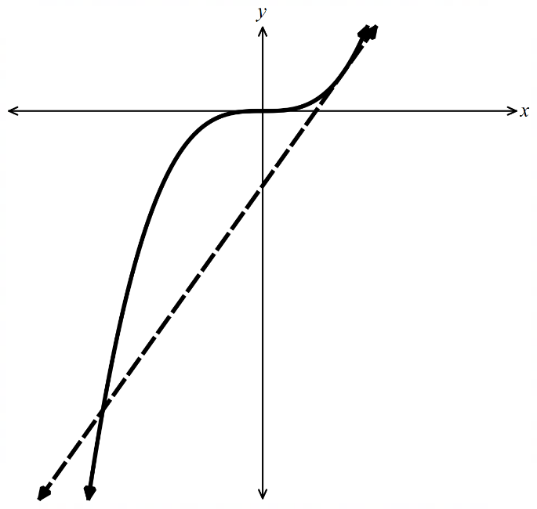
  - Find the area enclosed between the curve and the tangent.
$$y = x^{3}$$
$$y' = 3x²$$
$$At x = 2: y = 8, y^{'}= 12$$
$$y - 8 = 12\left(x - 2\right)$$
$$y = 12x - 16$$

$$x^{3}= 12x - 16$$
$$x^{3}- 12x + 16 = 0$$
$${\left(x - 2\right)}^{2} is a factor \left(tangent touches at x = 2\right).$$
$$x³ - 12x + 16 = {\left(x - 2\right)}^{2}\left(x + 4\right)$$
$$x = -4: y = {\left(-4\right)}^{3}= -64$$
$$Intersects again at \left(-4, -64\right).$$

$$\int_{-4}^{2}{\left(x^{3}- \left(12x - 16\right)\right)}dx = \int_{-4}^{2}{\left(x^{3}- 12x + 16\right)}dx$$
$$= {\left[\frac{x^{4}}{4}- 6x^{2}+ 16x\right]}_{-4}^{2}$$
$$= (4 - 24 + 32) - \left(64 - 96 - 64\right)$$
$$= 108 u²$$

- Consider $y = x³ - 3$ and $y = -x² + 10x - 11.$
  - Show by substitution that the curves intersect where $x = -4, 1$ and $2$.
  - Sketch the curves showing intersection points.
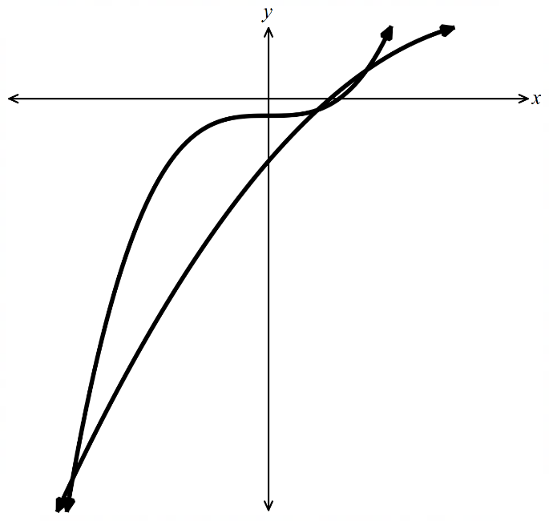
  - Find the area enclosed by the two curves.
$$Set x^{3}- 3 = -x^{2}+ 10x - 11$$
$$x^{3}+ x^{2}- 10x + 8 = 0$$
$$x = -4: -64 + 16 + 40 + 8 = 0$$
$$x = 1: 1 + 1 - 10 + 8 = 0$$
$$x = 2: 8 + 4 - 20 + 8 = 0$$

$$Intersection points:$$
$$x = -4: y = (-4)³ - 3 = -67 → \left(-4, -67\right)$$
$$x = 1: y = 1 - 3 = -2 → \left(1, -2\right)$$
$$x = 2: y = 8 - 3 = 5 → \left(2, 5\right)$$

$$Area = \int_{-4}^{1}{\left(\left(x^{3}- 3\right)- \left(-x^{2}+ 10x - 11\right)\right)}dx + \int_{1}^{2}{\left(\left(-x^{2}+ 10x - 11\right)- \left(x^{3}- 3\right)\right)}dx$$
$$= \int_{-4}^{1}{\left(x^{3}+ x^{2}- 10x + 8\right)}dx + \int_{1}^{2}{\left(-x^{3}- x^{2}+ 10x - 8\right)}dx$$

$$\int_{-4}^{1}{\left(x^{3}+ x^{2}- 10x + 8\right)}dx ={\left[\frac{x^{4}}{4}+\frac{x^{3}}{3}- 5x^{2}+ 8x\right]}_{-4}^{1}$$
$$=\frac{43}{12}- \left(-\frac{208}{3}\right)=\frac{875}{12}$$
$$\int_{1}^{2}{\left(-x^{3}- x^{2}+ 10x - 8\right)}dx = -{\left[\frac{x^{4}}{4}+\frac{x^{3}}{3}- 5x^{2}+ 8x\right]}_{1}^{2}$$
$$= -\left(\frac{32}{12}-\frac{43}{12}\right)=\frac{11}{12}$$

$$Area =\frac{875}{12}+\frac{11}{12}=\frac{443}{6}u^{2}$$

  - Find the points of intersection of $y = x^{2}\left(1 - x\right)$ and $y = x{\left(1 - x\right)}^{2}$.
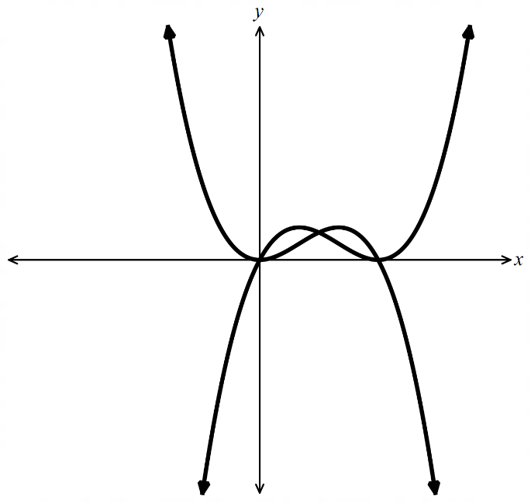
  - Find the area bounded by the two curves.
$$x²(1 - x) = x{\left(1 - x\right)}^{2}$$
$$x^{2}\left(1 - x\right)- x{\left(1 - x\right)}^{2}= 0$$
$$x\left(1 - x\right)\left[x - \left(1 - x\right)\right]= 0$$
$$x\left(1 - x\right)\left(2x - 1\right)= 0$$
$$x = 0, x = 1, x =\frac{1}{2}$$
$$x = 0: y = 0 → \left(0, 0\right)$$
$$x =\frac{1}{2}: y = \left(\frac{1}{4}\right)\left(\frac{1}{2}\right)=\frac{1}{8}→ \left(\frac{1}{2},\frac{1}{8}\right)$$
$$x = 1: y = 0 → \left(1, 0\right)$$

$$Let f(x) = x²(1 - x) and g(x) = x(1 - x)²$$
$$f(x) - g(x) = x(1 - x)(x - (1 - x)) = x\left(1 - x\right)\left(2x - 1\right)$$
$$On \left[0,\frac{1}{2}\right]: \left(2x - 1\right)< 0, so f < g \left(second curve above\right)$$
$$On \left[\frac{1}{2}, 1\right]: \left(2x - 1\right)> 0, so f > g \left(first curve above\right)$$
$$By symmetry, both regions have equal area.$$
$$Area = 2\int_{0}^{\frac{1}{2}}{\left(x{\left(1 - x\right)}^{2}- x^{2}\left(1 - x\right)\right)}dx$$
$$= 2\int_{0}^{\frac{1}{2}}{x\left(1 - x\right)\left(1 - 2x\right)}dx$$
$$= 2\int_{0}^{\frac{1}{2}}{\left(x - 3x^{2}+ 2x^{3}\right)}dx$$
$$= 2{\left[\frac{x^{2}}{2}- x^{3}+\frac{x^{4}}{2}\right]}_{0}^{\frac{1}{2}}$$
$$= 2\left(\frac{1}{8}-\frac{1}{8}+\frac{1}{32}\right)$$
$$=\frac{1}{16} u^{2}$$

Volumes of Rotation

- Review
- Calculate volume of solids
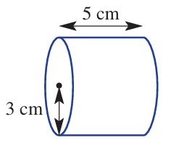 | 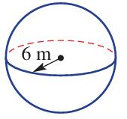 | 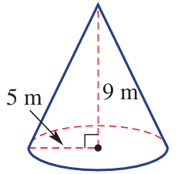

- Evaluate definite Integrals
$$\int_{1}^{4}{x^{2}-3}dx$$  12 | $$\int_{1}^{4}{e^{2x}}dx$$  $$\frac{e^{8}-e^{2}}{2}$$
$$\int_{1}^{4}{{\left(x-3\right)}^{2}}dx$$  3 | $$\int_{1}^{4}{{\left(x^{2}-3\right)}^{2}}dx$$  $$\frac{528}{5}$$

- Investigation Volume of solids of revolution
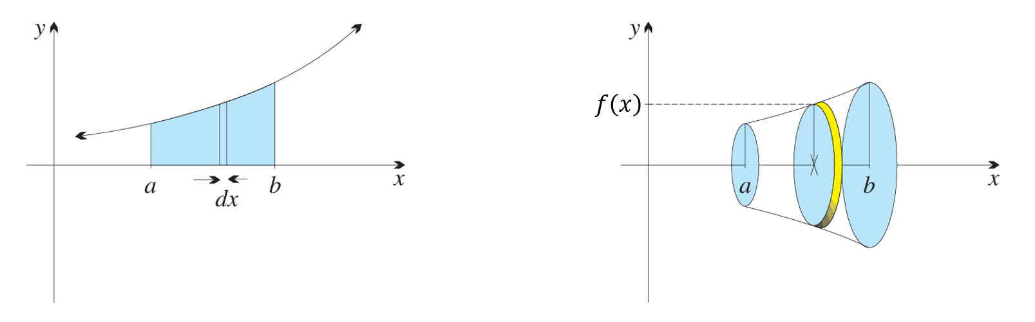
When you rotate the area under a curve around an axis, you create a solid of revolution.

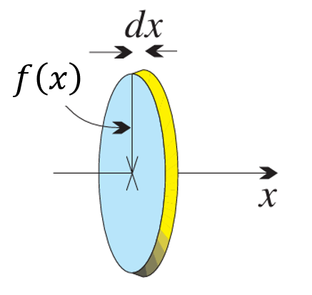
This solid is made up of thin circular slices.
The radius of each slice is: ………………
The thickness of each slice is: ……………
So, the volume of each slice is: ………………

We add up every slice between $x=a$ and $x=b,$ which is equivalent to integrating:
$$V=\int_{a}^{b}{π{\left[f\left(x\right)\right]}^{2}}dx \\ =π\int_{a}^{b}{{\left[f\left(x\right)\right]}^{2}}dx$$

Let’s use this formula to derive the volumes of a cone and sphere:
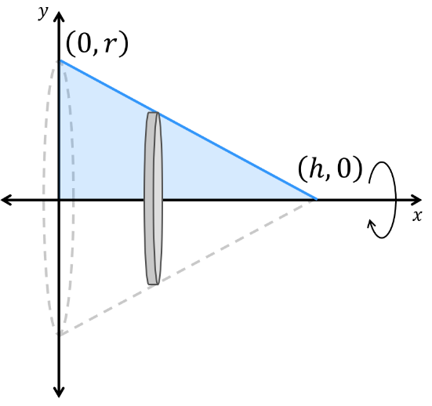 | 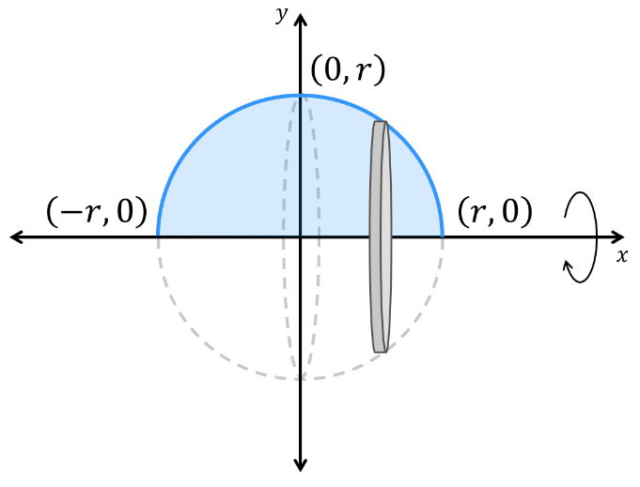

- Volume of Solids Rotated about $x$ axis
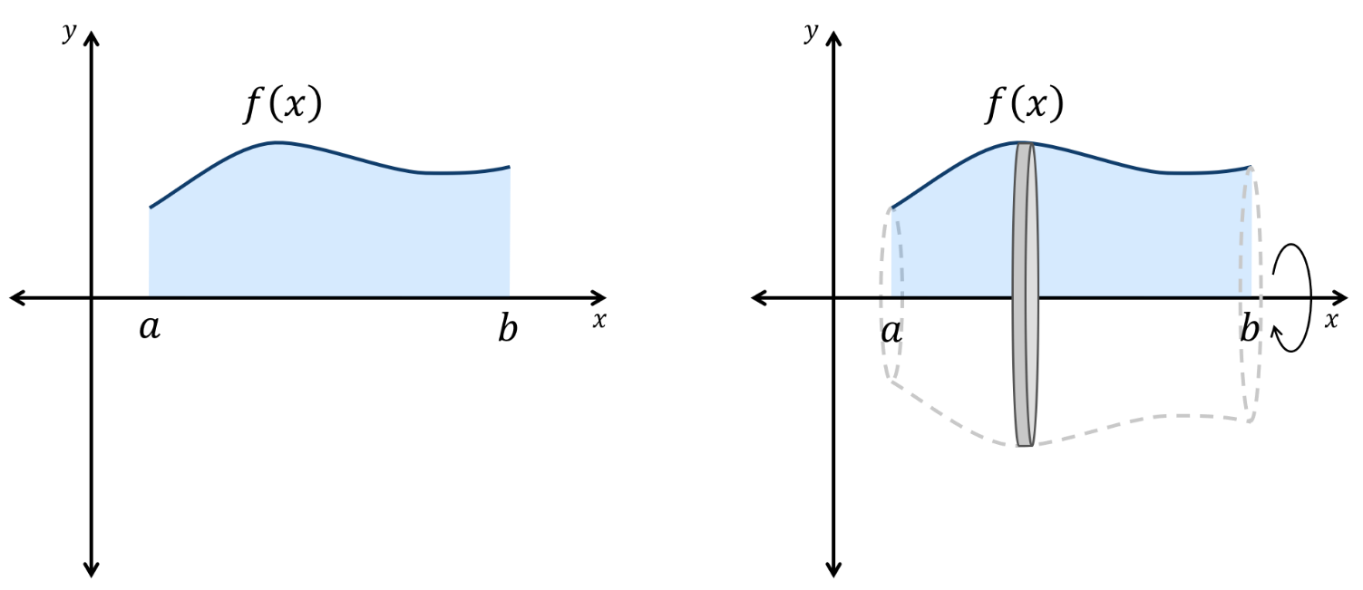
Rotating $y=f\left(x\right)$ about $x$-axis
between $x=a$ and $x=b$:

$$V=π\int_{a}^{b}{y^{2}}dx$$

- Example Calculate volumes of rotation about $x$-axis
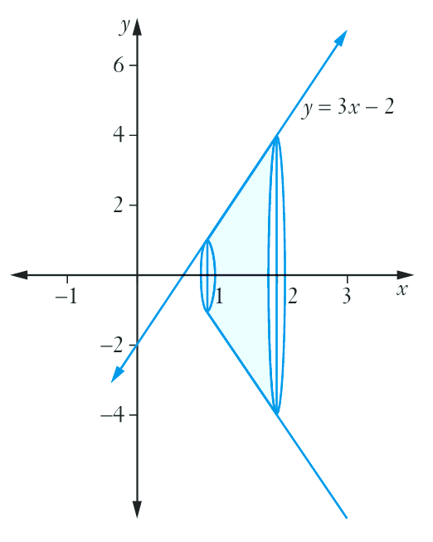
Find the volume of the solid formed when the line $y=3x-2$
is rotated about the $x$-axis from $x=1$ to $x=2$
$$V=π\int_{1}^{2}{{\left(3x-2\right)}^{2}}dx$$
$$=π{\left[\frac{{\left(3x-2\right)}^{3}}{9}\right]}_{1}^{2}$$
$$=\frac{π}{9}{\left[ {\left(3x-2\right)}^{3}\begin{matrix} \\ \\ \end{matrix}\right]}_{1}^{2}$$
$$=\frac{π}{9}\left(4^{3}-1^{3}\right)$$
$$=7π {units}^{3}$$

- Guided Practice
Find the volume of the solid formed by rotating:
- $x^{2}+y^{2}=9$  between $x=1$  and $x=3$.  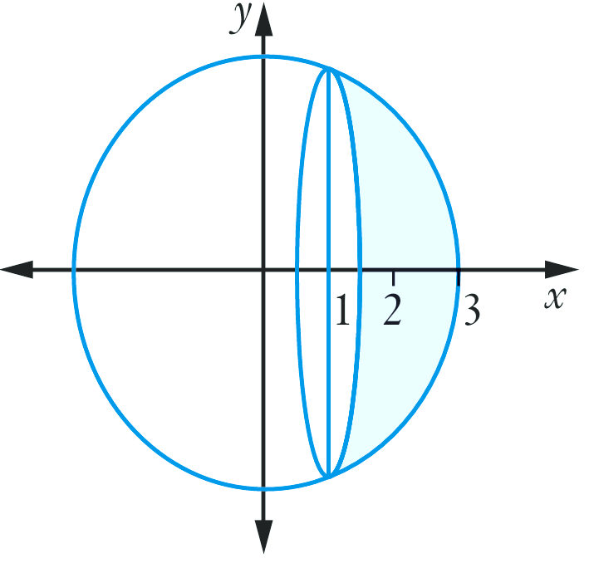  $$\frac{28π}{3} u^{3}$$ | - $y=e^{x}$  between $x=0$  and $x=2$.  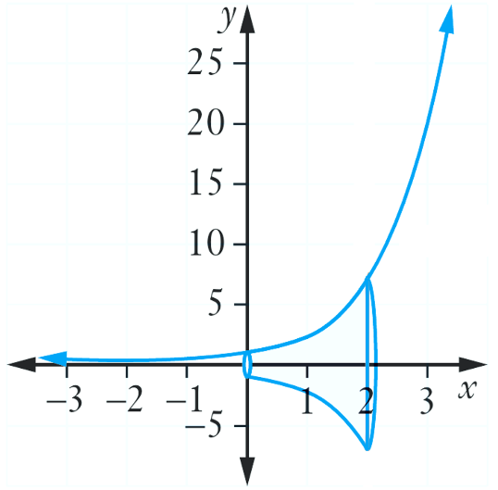  $$\frac{π}{2}\left(e^{4}-1\right) u^{3}$$
- Volume of Solids Rotated about $y$ axis
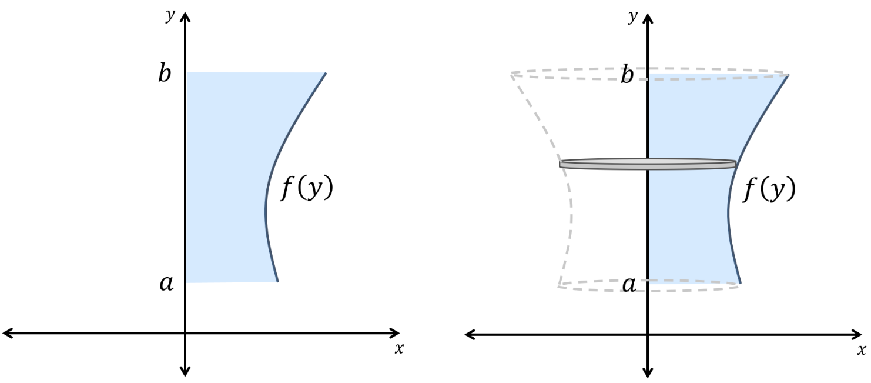
Rotating $x=f\left(y\right)$ about $y$-axis
between $x=a$ and $x=b$:

$$V=π\int_{a}^{b}{x^{2}}dy$$

- Example Calculate volumes of rotation about $y$-axis
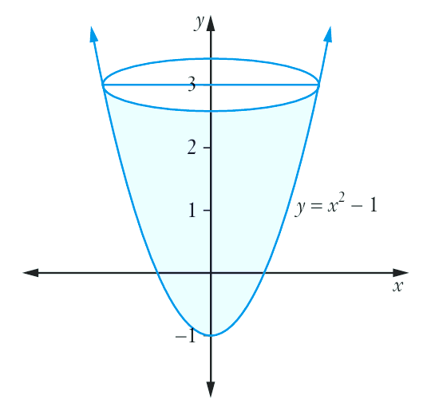
Find the volume of the solid formed when the line $y=x^{2}-1$
is rotated about the $y$-axis from $y=-1$ to $y=3$
$$x^{2}=y+1$$
$$V=π\int_{-1}^{3}{y+1}dy$$
$$=π{\left[\frac{y^{2}}{2}+y\right]}_{-1}^{3}$$
$$=π\left(\left(\frac{9}{2}+3\right)-\left(\frac{1}{2}-1\right)\right)$$
$$=8π {units}^{3}$$

- Guided Practice
Find the volume of the solid formed by rotating these regions about the $y$ axis:
- $y=5-x^{2}$  between $y=0$  and $y=5$.  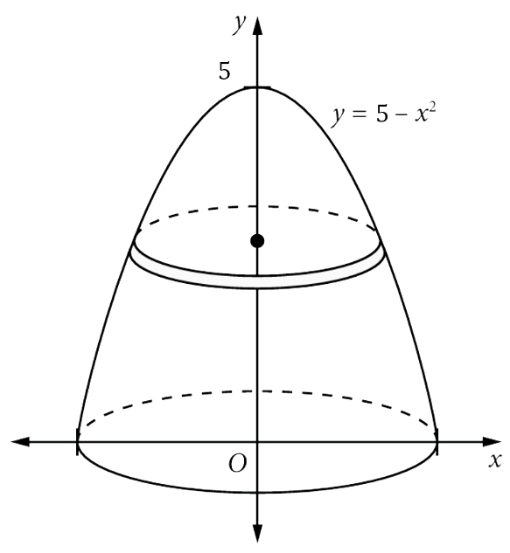  $$\frac{25π}{2} u^{3}$$ | - $y=3-2x$  between $y=-1$  and $y=3$.  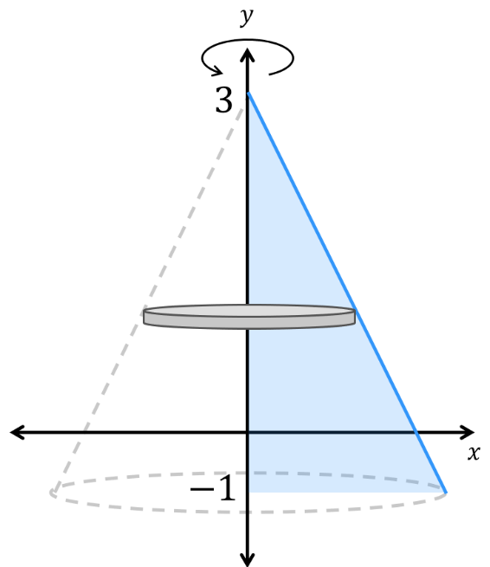  $$\frac{16π}{3} u^{3}$$

Foundation

  - Consider the region bounded by the line $y = 3x$
and the $x$-axis between $x = 0$ and $x = 3$.
  - When this region is rotated about the $x$-axis, a right circular cone is formed.
Find the radius and height of the cone and hence find its volume using $V=\frac{1}{3}πr^{2}h$
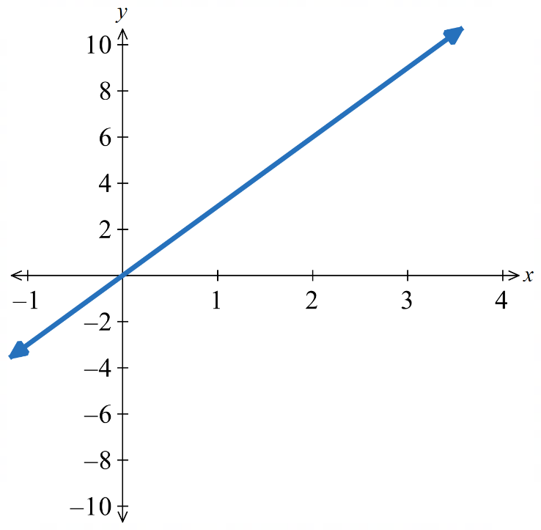
  - Evaluate $π\int_{0}^{3}{9x^{2}}dx$ to check your answer.

$$At x = 3: y = 9, so r = 9, h = 3.$$
$$V =\frac{1}{3}π\left(9^{2}\right)\left(3\right)= 81π u^{3}$$

$$π\int_{0}^{3}{9x^{2}}dx = π{\left[3x^{3}\right]}_{0}^{3}= 81π u^{3}$$

  - Consider the region bounded by the curve $y=\sqrt{9 - x^{2}}$
and the $x$-axis between $x=-3$ and $x=3$.
  - When this region is rotated about the $x$-axis, a sphere is formed.
Find the radius of the sphere and hence find its volume using $V=\frac{4}{3}πr^{3}$
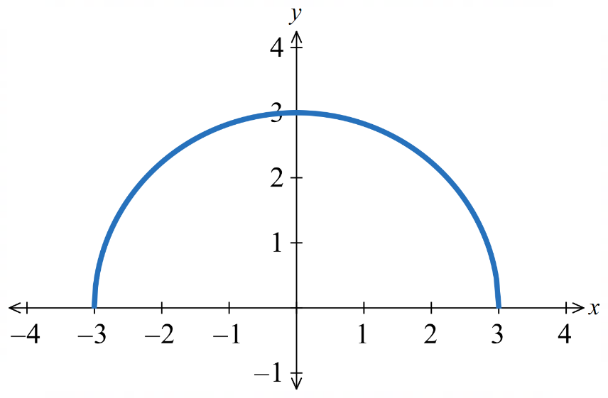
  - Evaluate $π\int_{-3}^{3}{\left(9 - x^{2}\right)}dx$ to check your answer.
$$r = 3.$$
$$V = \left(\frac{4}{3}\right)π\left(3^{3}\right)= 36π u^{3}$$

$$π\int_{-3}^{3}{\left(9 - x^{2}\right)}dx = π{\left[9x -\frac{x^{3}}{3}\right]}_{-3}^{3}$$
$$= π\left(18 + 18\right)= 36π u^{3}$$

- Calculate the volume generated when each shaded region is rotated about the $x$-axis.
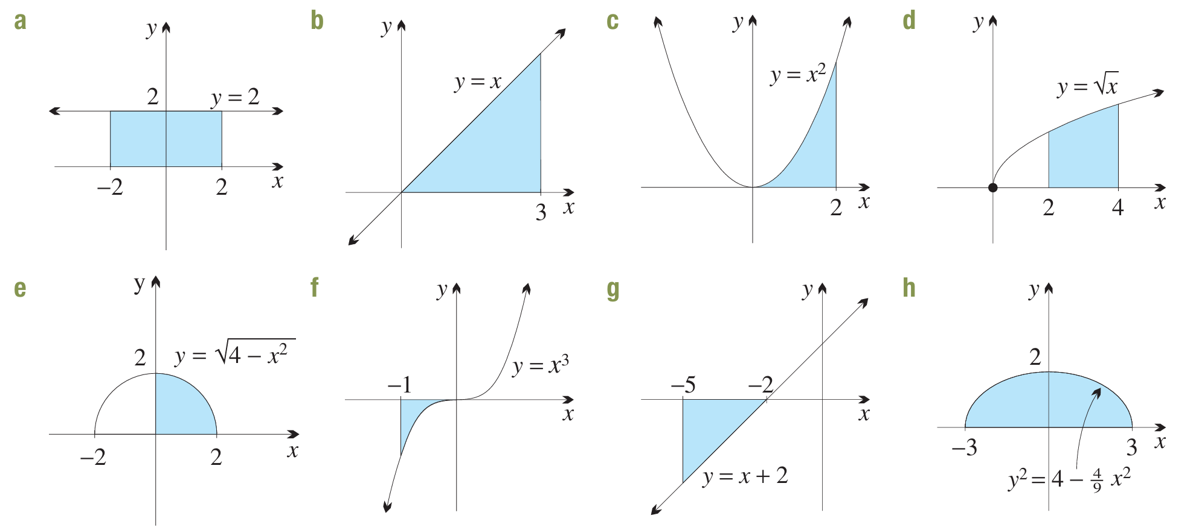  $$16π u^{3}$$ | $$9π u^{3}$$ | $$\frac{32π}{5} u^{3}$$
$$6π u^{3}$$ | $$\frac{16π}{3} u^{3}$$ | $$\frac{π}{7} u^{3}$$
$$9π u^{3}$$ | $$16π u^{3}$$

- Calculate the volume generated when each shaded region is rotated about the $y$-axis.
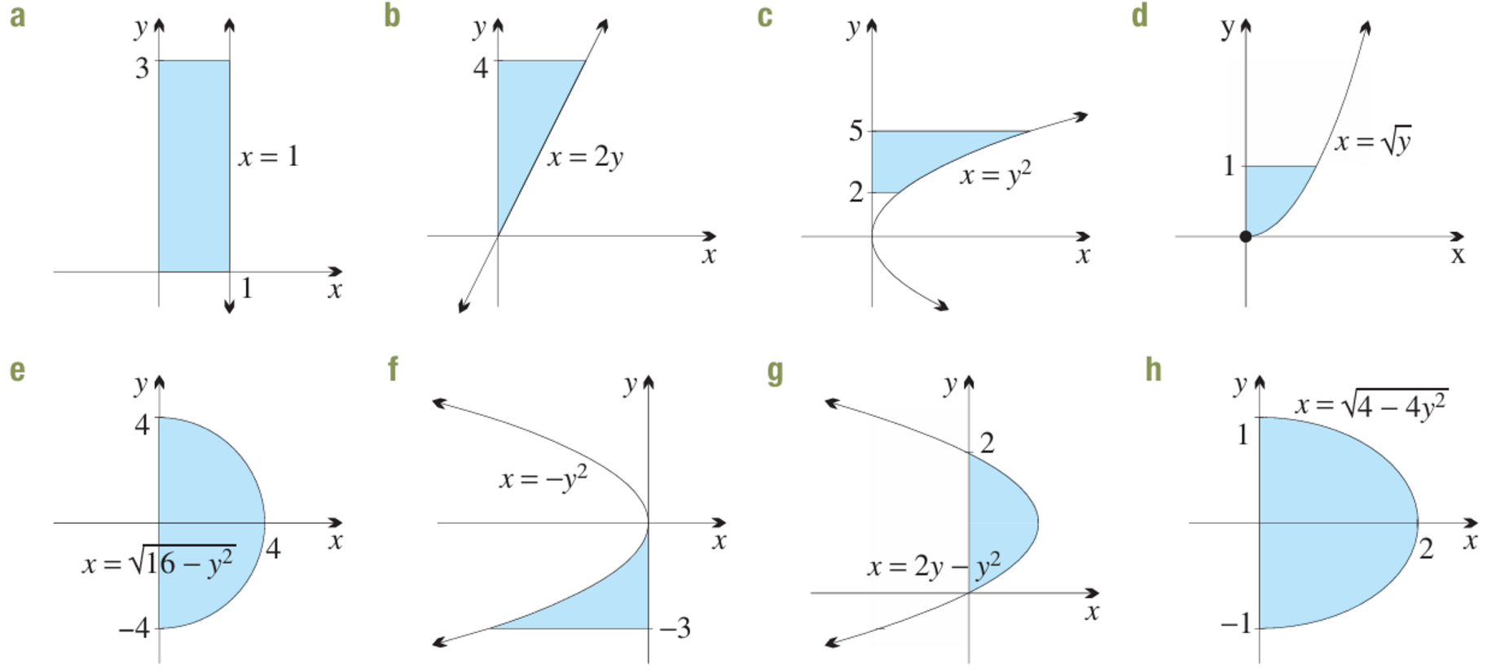  $$3π u^{3}$$ | $$\frac{256π}{3} u^{3}$$ | $$8π u^{3}$$
$$\frac{π}{2} u^{3}$$ | $$\frac{256π}{3} u^{3}$$ | $$\frac{243π}{5} u^{3}$$
$$\frac{16π}{5} u^{3}$$ | $$\frac{16π}{3} u^{3}$$
- The region between the curve $y=e^{x}$ and the $x$-axis from $x=0$ to $x=1$ is rotated about the
$x$-axis. Find the volume of the solid generated.
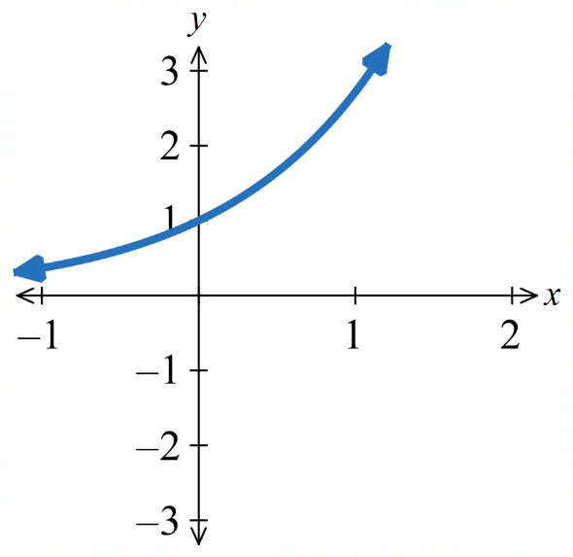

$$V = π\int_{0}^{1}{e^{2x}}dx = π{\left[\frac{e^{2x}}{2}\right]}_{0}^{1}$$
$$= \left(\frac{π}{2}\right)\left(e^{2}- 1\right)u^{3}$$

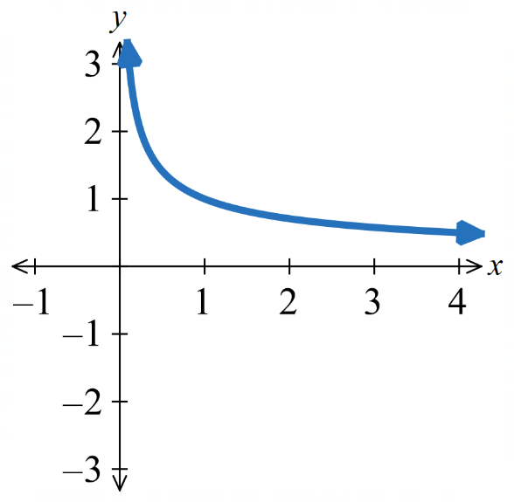
- Find the volume generated when the region between the curve $y =\frac{1}{\sqrt{x}}$ and the $x$-axis, from
$x=2$ to $x=4$, is rotated about the $x$-axis.

$$y^{2}=\frac{1}{x}$$
$$V = π\int_{2}^{4}{\left(\frac{1}{x}\right)}dx = π{\left[ln x\right]}_{2}^{4}$$
$$= π ln 2 u^{3}$$
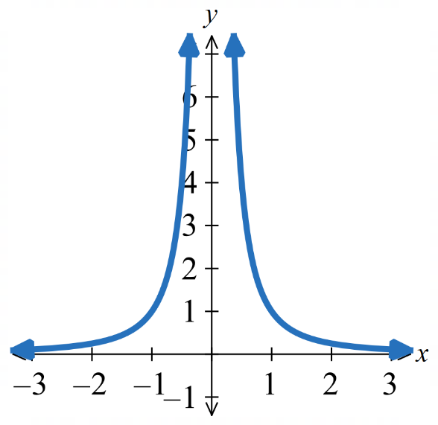
- The region between the curve $y =\frac{1}{x^{2}}$ (a truncus) and the $y$-axis from $y=1$ to $y=6$ is rotated about the $y$-axis. Calculate the exact volume of the solid formed.

$$x^{2}=\frac{1}{y}$$
$$V = π\int_{1}^{6}{\left(\frac{1}{y}\right)}dy = π{\left[ln y\right]}_{1}^{6}$$
$$= π ln 6 u^{3}$$

Development

  - Write $tan²x$ in terms of $sec²x.$
  - The region bounded by the curve $y=tan x$, the $x$-axis and the vertical line $x =\frac{π}{3}$ is rotated about the $x$-axis. Find the volume of the solid generated.

$$a tan²x = sec²x - 1$$
$$V = π\int_{0}^{\frac{π}{3}}{\left(sec^{2}x - 1\right)}dx = π{\left[tan x - x\right]}_{0}^{\frac{π}{3}}$$
$$= π\left(\sqrt{3}-\frac{π}{3}\right)u^{3}$$

  - Write $sin²x$ in terms of $cos 2x$.
  - The region bounded by the curve $y = sin x$, the $x$-axis and the vertical line $x =\frac{π}{2}$ is rotated about the $x$-axis. Find the volume of the solid generated.
$$\sin^{2}x =\frac{1}{2}-\frac{1}{2}cos 2x$$
$$V = π\int_{0}^{\frac{π}{2}}{\left(\frac{1}{2}- \left(\frac{1}{2}\right)cos 2x\right)}dx = π{\left[\frac{x}{2}-\frac{sin 2x}{4}\right]}_{0}^{\frac{π}{2}}$$
$$=\frac{π^{2}}{4}u^{3}$$
- Find the volume of the solid formed by rotating the region with the given boundaries about the $x$-axis. (A sketch of each region will be needed.)
- $y=x+3,x=3,x=5,y=0$  $$V = π\int_{3}^{5}{{\left(x + 3\right)}^{2}}dx$$  $$= π{\left[\frac{{\left(x + 3\right)}^{3}}{3}\right]}_{3}^{5}$$  $$=\frac{296π}{3}u^{3}$$ | - $y=1+\sqrt{x},x=1,x=4,y=0$  $$V = π\int_{1}^{4}{\left(1 + 2x^{\frac{1}{2}}+ x\right)}dx$$  $$= π{\left[x + \left(\frac{4}{3}\right)x^{\frac{3}{2}}+\frac{x^{2}}{2}\right]}_{1}^{4}$$  $$=\frac{119π}{6}u^{3}$$
- $y=5x-x^{2},y=0$  Zeros at $x = 0, 5.$  $$V = π\int_{0}^{5}{\left(25x^{2}- 10x^{3}+ x^{4}\right)}dx$$  $$= π{\left[\frac{25x^{3}}{3}- \left(\frac{5}{2}\right)x^{4}+\frac{x^{5}}{5}\right]}_{0}^{5}$$  $$=\frac{625π}{6}u^{3}$$ | - $y=x^{3}-x,y=0$  Zeros at $x = -1, 0, 1; (x³ - x)²$ is even,  so integrate on [0, 1] and double.  $$V = 2π\int_{0}^{1}{\left(x^{6}- 2x^{4}+ x^{2}\right)}dx$$  $$= 2π{\left[\frac{x^{7}}{7}-\frac{2x^{5}}{5}+\frac{x^{3}}{3}\right]}_{0}^{1}$$  $$=\frac{16π}{105}u³$$

mastery
- Find the volume of the solid formed by rotating the region with the given boundaries about the $y$-axis. (A sketch of each region will be needed.)
- $x=y-2,y=1,x=0$  $x = 0$when $y = 2$; radius $= 2 - y$ for $y ∈ [1, 2].$  $$V = π\int_{1}^{2}{{\left(2 - y\right)}^{2}}dy$$  $$= π{\left[-\frac{{\left(2 - y\right)}^{3}}{3}\right]}_{1}^{2}$$  $$=\frac{π}{3}u^{3}$$ | - $x=y²+1,y=0,y=1,x=0$  $$V = π\int_{0}^{1}{{\left(y^{2}+ 1\right)}^{2}}dy$$  $$= π\int_{0}^{1}{\left(y^{4}+ 2y^{2}+ 1\right)}dy$$  $$= π{\left[\frac{y^{5}}{5}+\frac{2y^{3}}{3}+ y\right]}_{0}^{1}$$  $$=\frac{28π}{15}u^{3}$$
- $x=y(y-3),x=0$  $x = y(y - 3) ≤ 0$ on $(0, 3);$ radius $= y(3 - y)$.  $$V = π\int_{0}^{3}{y^{2}{\left(3 - y\right)}^{2}}dy$$  $$= π\int_{0}^{3}{\left(9y^{2}- 6y^{3}+ y^{4}\right)}dy$$  $$= π{\left[3y^{3}- \left(\frac{3}{2}\right)y^{4}+\frac{y^{5}}{5}\right]}_{0}^{3}$$  $$=\frac{81π}{10}u^{3}$$ | - $y=1-x²,y=0$  $x² = 1 - y, y$ from 0 to 1.  $$V = π\int_{0}^{1}{\left(1 - y\right)}dy$$  $$= π{\left[y -\frac{y^{2}}{2}\right]}_{0}^{1}$$  $$=\frac{π}{2}u^{3}$$

- A vat is designed by rotating about the $x$-axis the region between the curve $y=1+\frac{1}{x}$ and the $x$-axis from $x=\frac{1}{2}$ to $x=3$. Show that its volume is $\left(\frac{π}{6}\right)\left(25 + 12 ln 6\right) u³$.

$$V = π\int_{\frac{1}{2}}^{3}{\left(1 +\frac{2}{x}+\frac{1}{x^{2}}\right)}dx = π{\left[x + 2 ln x -\frac{1}{x}\right]}_{\frac{1}{2}}^{3}$$
$$= π\left(\left(\frac{8}{3}+ 2 ln 3\right)- \left(-\frac{3}{2}- 2 ln 2\right)\right)$$
$$=\frac{π}{6}\left(25 + 12 ln 6\right)$$

- A metal stud is created by rotating about the $x$-axis the region between the curve $y = e^{x} - e^{-x}$ and the $x$-axis from $x=0$ to $x=\frac{1}{2}$. Show that the volume of the stud is $\left(\frac{π}{2}\right)\left(e-2-e^{-1}\right) u^{3}.$

$$y^{2}= e^{2x}- 2 + e^{-2x}$$
$$V = π\int_{0}^{\frac{1}{2}}{\left(e^{2x}- 2 + e^{-2x}\right)}dx$$
$$= π{\left[\frac{e^{2x}}{2}- 2x -\frac{e^{-2x}}{2}\right]}_{0}^{\frac{1}{2}}$$
$$= π\left(\frac{e}{2}- 1 -\frac{e^{-1}}{2}\right)= \frac{π}{2}\left(e - 2 - e^{-1}\right)$$

- A champagne flute is designed by rotating about the $x$-axis the region between the curve $y = 4 + 4 sin\left(\frac{x}{4}\right)$ and the $x$-axis from$x=4π$ to $x=6π$. Find, correct to 4 significant figures, the capacity of the flute if 1 unit = 1 cm.

$$y^{2}= 16{\left(1 + sin\left(\frac{x}{4}\right)\right)}^{2}$$
$$=16\left(1+2\sin\left(\frac{x}{4}\right)+\sin^{2}\left(\frac{x}{4}\right)\right)$$
Using double angle rule: $\sin^{2}\left(\frac{x}{4}\right)=\frac{1}{2}-\frac{1}{2}\cos\left(\frac{x}{2}\right)$
$$= 16\left(\frac{3}{2}+ 2 sin\left(\frac{x}{4}\right)-\frac{1}{2}cos\left(\frac{x}{2}\right)\right)$$
$$V = 16π\int_{4π}^{6π}{\left(\frac{3}{2}+ 2 sin\left(\frac{x}{4}\right)-\frac{1}{2}cos\left(\frac{x}{2}\right)\right)} dx$$
$$= 16π{\left[\frac{3x}{2}- 8 cos\left(\frac{x}{4}\right)- sin\left(\frac{x}{2}\right)\right]}_{4π}^{6π}$$
$$= 16π\left(3π - 8\right)≈ 71.62 mL$$

Rotating Area between Two Curves

- Review
- Calculate area between two curves
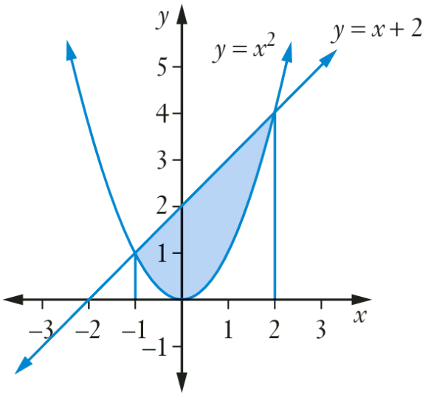
Find the area enclosed between the curve $y = x^{2}$ and the line $y=x+2$

4.5 u²
- Calculate volume of solid of revolution
Rotate the given region about the $x$ axis.
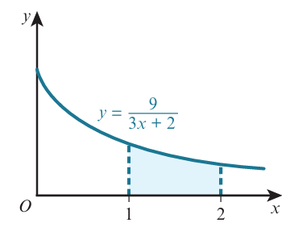

$$\frac{81π}{40} u^{3}$$
- Calculate area of an annulus
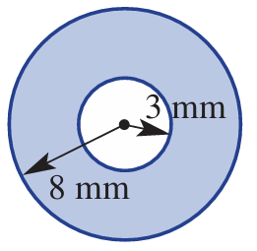 | 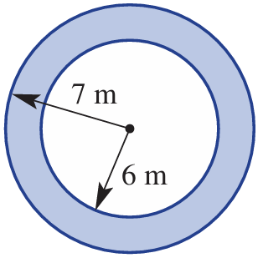

- Calculate volume of composite solid
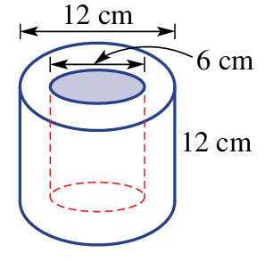 | 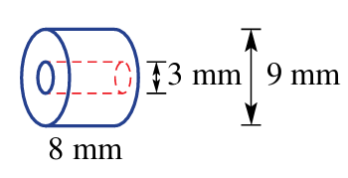

- Investigation Volume of solids of revolution: area between curves
When you rotate the area between two curves around an axis, you create a hollow solid:
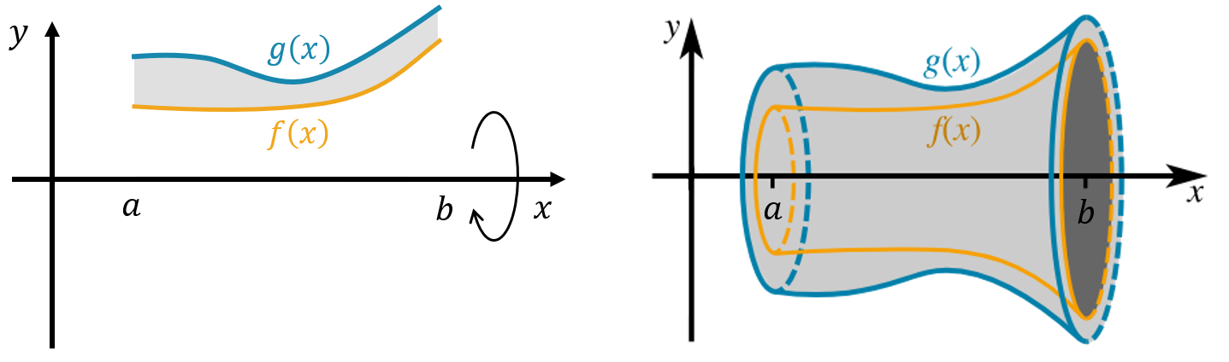

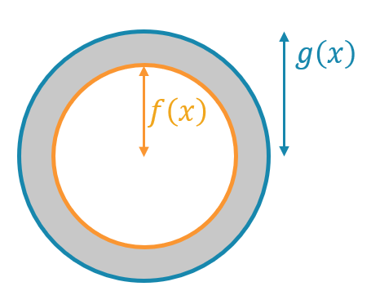
The cross-section of this solid is an annulus. Consider $g\left(x\right)≥f\left(x\right)$:
The outer radius is: ……………
The inner radius is: ……………
The area of the annulus is: ………………
The volume of a slice is: ………………

We add up every slice between $x=a$ and $x=b,$ which is equivalent to integrating:
$$V=\int_{a}^{b}{π\left({\left[g\left(x\right)\right]}^{2}-{\left[f\left(x\right)\right]}^{2}\right)}dx \\ V=π\int_{a}^{b}{{\left[g\left(x\right)\right]}^{2}-{\left[f\left(x\right)\right]}^{2}}dx$$

- Volumes of Revolution: Area between two curves
Rotation about $x$ axis | Rotation about $y$ axis
$$y_{2}≥y_{1}$$  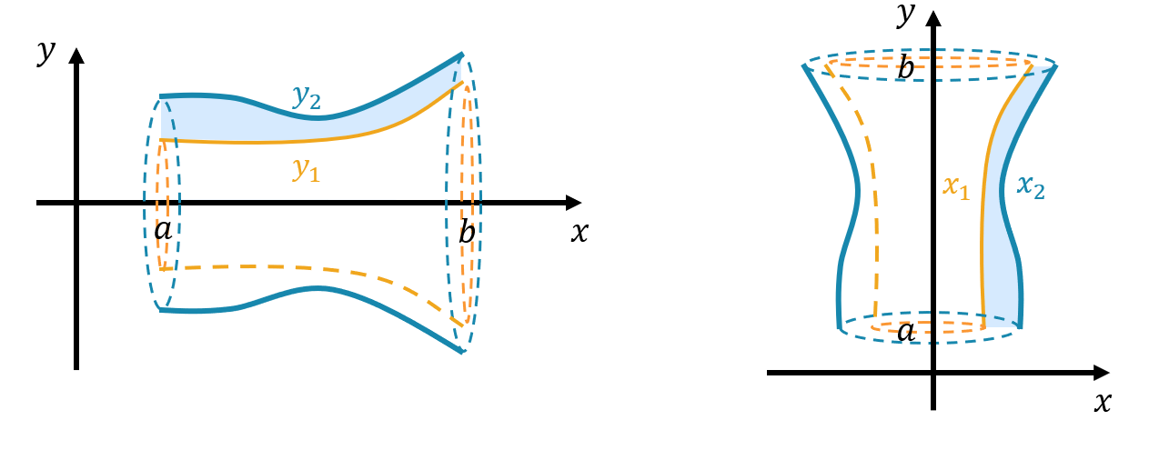  $$V=π\int_{a}^{b}{\left(y_{2}^{2}-y_{1}^{2}\right)}dx$$ | $$x_{2}≥x_{1}$$  $$V=π\int_{a}^{b}{\left(x_{2}^{2}-x_{1}^{2}\right)}dy$$

- Example Calculate volume of solids of revolution: area between curves
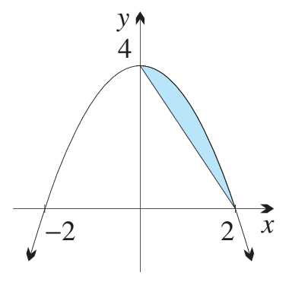
The area between the curve $y=4-x^{2}$ and the line $y=4-2x$ between $x=0$ and $x=2$ are rotated about the $x$-axis. Find the volume generated.
$$V=π\int_{0}^{2}{\left(y_{2}^{2}-y_{1}^{2}\right)}dx where y_{2}=4-x^{2} and y_{1}=4-2x$$
$$=π\int_{0}^{2}{\left({\left(4-x^{2}\right)}^{2}-{\left(4-2x\right)}^{2}\right)}dx$$
$$=π\int_{0}^{2}{\left(x^{4}-12x^{2}+16x\right)}dx$$
$$=π{\left[\frac{x^{5}}{5}-4x^{3}+9x^{2}\right]}_{0}^{2}$$
$$=π\left(\frac{32}{5}-32+32-\left(0-0+0\right)\right)$$
$$=\frac{32π}{5} u^{3}$$

- Guided Practice
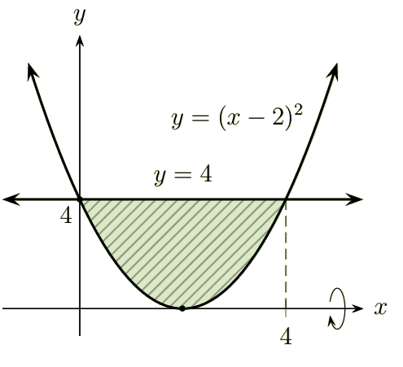
- The shaded region bounded by $y={\left(x-2\right)}^{2}$ and $y=4$ between $x=0$ and $x=4$ is rotated about the $x$ axis. Find the volume of this solid.

$$\frac{256π}{5} u^{3}$$
- The area between $y=4-x^{2}$ and $y=4-2x$ between $y=0$ and $y=4$ are rotated about the $y$-axis. Find the volume generated.

$$\frac{8π}{3} u^{3}$$

- Investigation Volume of solids of revolution: further area between curves
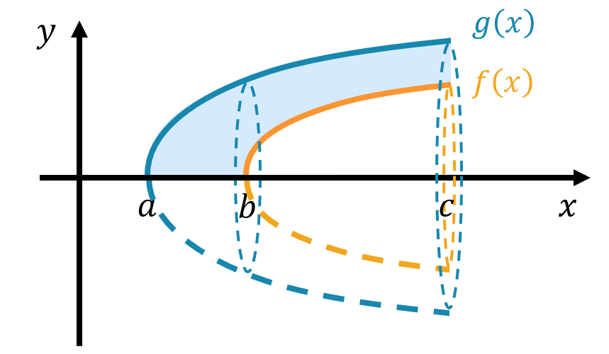
If the domain of the two functions are different, you must use two separate integrals.

Method 1: Split the region  Where both curves exist:  $$V_{1}=π\int_{b}^{c}{{\left[g\left(x\right)\right]}^{2}-{\left[f\left(x\right)\right]}^{2}}dx$$  Where only one curve exists:  $$V_{2}=π\int_{a}^{b}{{\left[g\left(x\right)\right]}^{2}}dx$$  $$V_{total}=V_{1}+V_{2}$$ | Method 2: Outer volume – Inner volume  $$V_{outer}=π\int_{a}^{c}{{\left[g\left(x\right)\right]}^{2}}dx$$  $$V_{inner}=π\int_{b}^{c}{{\left[f\left(x\right)\right]}^{2}}dx$$  $$V_{total}=V_{outer}-V_{inner}$$
The area bounded by $y=\sqrt{x-1}$ and $y=\sqrt{x-3}$ between $x=1$ and $x=5$ are rotated about the $x$ axis. Find the volume of the solid.
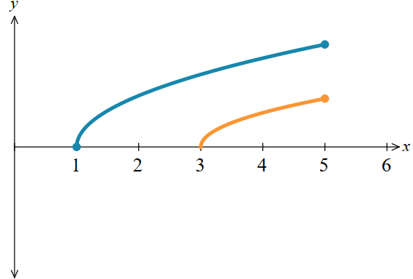

Method 1  $$6π u^{3}$$ | Method 2  $$6π u^{3}$$

Foundation
- The region $R$ is bounded by the parabola$y = x²$ and the $x$-axis from $x = 0$ to $x = 4$.
We will calculate the volume of this region rotated around the $y$-axis by:
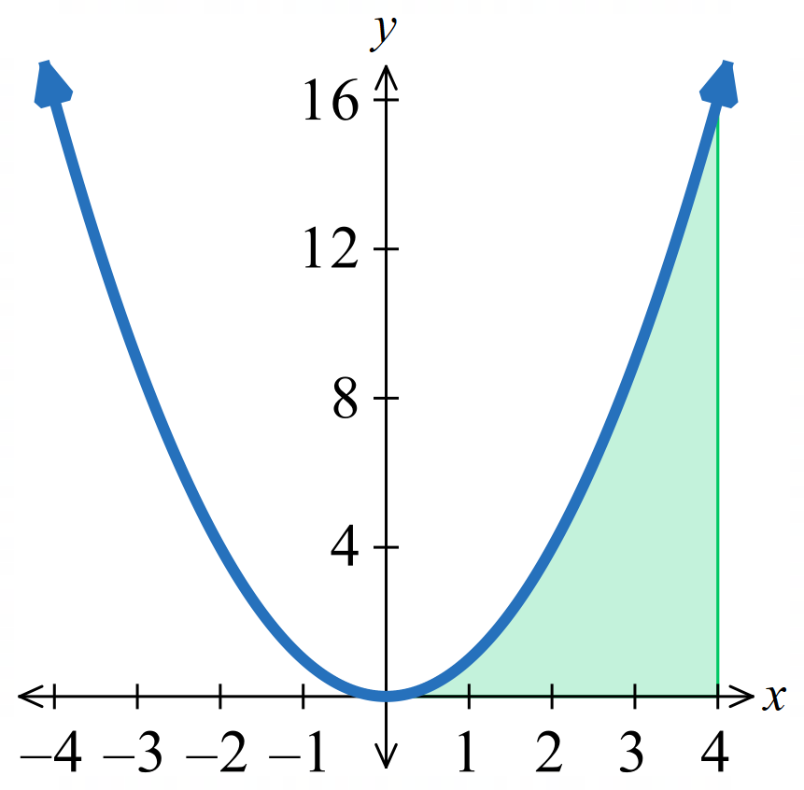
  - Find the outer volume: cylinder formed when the region between the line $x = 4$ and the $y$-axis from $y=0$ to $y=16$ is rotated about
the $y$-axis.

$$V = π\left(4^{2}\right)\left(16\right)= 256π u^{3}$$
  - Find the inner volume: the region between the parabola $y=x²$ and the $y$-axis from $y=0$ to $y=16$ is rotated about the $y$-axis.

x² = y; rotating about y-axis:
$$V = π\int_{0}^{16}{y}dy = π{\left[\frac{y^{2}}{2}\right]}_{0}^{16}= 128π u^{3}$$
  - Hence use parts a and b to find the volume of the solid formed when $R$ is rotated about the $y$-axis.

$$V = 256π - 128π = 128π u³$$
  - Calculate the same volume using $V=π\int_{a}^{b}{\left(x_{2}^{2}-x_{1}^{2}\right)}dy$
$$V=π\int_{0}^{16}{4^{2}}-y dy$$
$$=π{\left[16y-\frac{y^{2}}{2}\right]}_{0}^{16}$$
$$=128π u^{3}$$

- Find the volume of the solid generated by rotating each region about:
    - the $x$-axis
    - the $y$-axis
In some cases, a subtraction of volumes will be necessary.
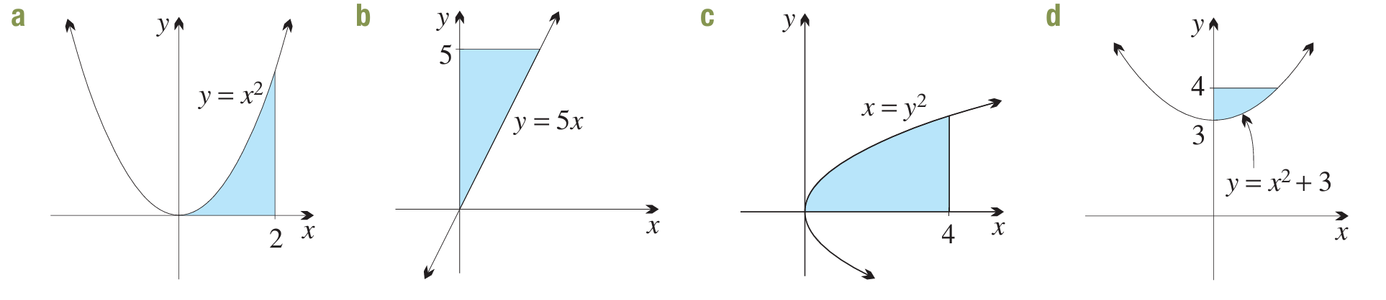
$$V = π\int_{0}^{2}{x^{4}}dx$$  $$= π{\left[\frac{x^{5}}{5}\right]}_{0}^{2}$$  $$=\frac{32π}{5}u^{3}$$ | Outer radius 2, inner radius $\sqrt{y}, y$ from 0 to 4:  $$V = π\int_{0}^{4}{\left(4 - y\right)}dy$$  $$= π{\left[4y -\frac{y^{2}}{2}\right]}_{0}^{4}$$  $$= 8π u^{3}$$
Outer radius 5, inner radius $5x, x$ from 0 to 1:  $$V = π\int_{0}^{1}{\left(25 - 25x^{2}\right)}dx$$  $$= 25π{\left[x -\frac{x^{3}}{3}\right]}_{0}^{1}$$  $$=\frac{50π}{3}u^{3}$$ | $x =\frac{y}{5}, y$ from 0 to 5:  $$V = π\int_{0}^{5}{{\left(\frac{y}{5}\right)}^{2}}dy$$  $$= \left(\frac{π}{25}\right){\left[\frac{y^{3}}{3}\right]}_{0}^{5}=\frac{5π}{3}u^{3}$$
$y = \sqrt{x}$, so $y² = x$:  $$V = π\int_{0}^{4}{x}dx$$  $$= π{\left[\frac{x^{2}}{2}\right]}_{0}^{4}$$  $$= 8π u^{3}$$ | Outer radius 4, inner radius $y², y$ from 0 to 2:  $$V = π\int_{0}^{2}{\left(16 - y^{4}\right)}dy$$  $$= π{\left[16y -\frac{y^{5}}{5}\right]}_{0}^{2}$$  $$=\frac{128π}{5}u^{3}$$
Outer radius 4, inner radius $x² + 3, x$ from 0 to 1:  $$V = π\int_{0}^{1}{\left(16 - {\left(x^{2}+ 3\right)}^{2}\right)}dx$$  $$= π\int_{0}^{1}{\left(7 - 6x^{2}- x^{4}\right)}dx$$  $$= π{\left[7x - 2x^{3}-\frac{x^{5}}{5}\right]}_{0}^{1}=\frac{24π}{5}u^{3}$$ | $x² = y - 3, y$ from 3 to 4:  $$V = π\int_{3}^{4}{\left(y - 3\right)}dy$$  $$= π{\left[\frac{{\left(y - 3\right)}^{2}}{2}\right]}_{3}^{4}=\frac{π}{2}u^{3}$$

Development

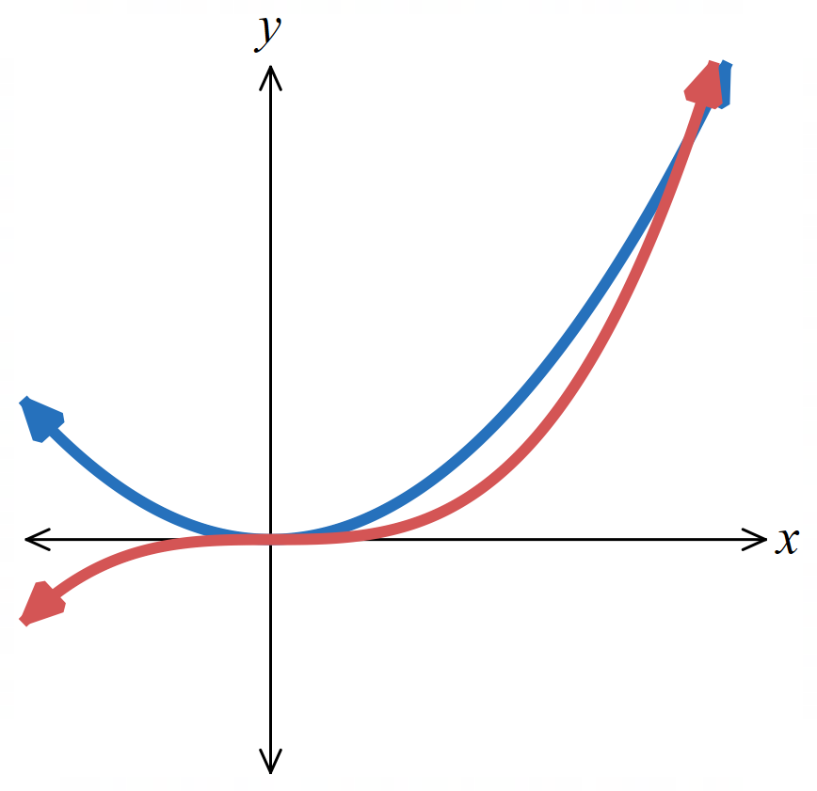
  - Consider the region bounded by the curves $y = x²$ and $y = x³.$
Find the points of intersection.

$$x^{2}=x^{3}$$
$$x^{2}\left(x-1\right)=0$$
Intersections at $x= 0, x=1$;
$∴(0,0)$ and $\left(1,1\right)$

  - Find the volume of the solid generated when this region is rotated about:
- the $x$-axis  $$x² > x³ on x∈(0, 1).$$  Outer radius $x²$, inner radius $x³:$  $$V = π\int_{0}^{1}{\left(x^{4}- x^{6}\right)}dx = π{\left[\frac{x^{5}}{5}-\frac{x^{7}}{7}\right]}_{0}^{1}$$  $$=\frac{2π}{35}u^{3}$$ | - the $y$-axis  $$y = x^{2}→x = y^{\frac{1}{2}};$$  $$y = x^{3}→x = y^{\frac{1}{3}}.$$  $For y∈ \left(0, 1\right), y^{\frac{1}{3}}> y^{\frac{1}{2}},$  outer radius $y^{\frac{1}{3}},$ inner radius $y^{\frac{1}{2}}:$  $$V = π\int_{0}^{1}{\left(y^{\frac{2}{3}}- y\right)}dy = π{\left[\frac{3y^{\frac{5}{3}}}{5}-\frac{y^{2}}{2}\right]}_{0}^{1}$$  $$=\frac{π}{10}u^{3}$$

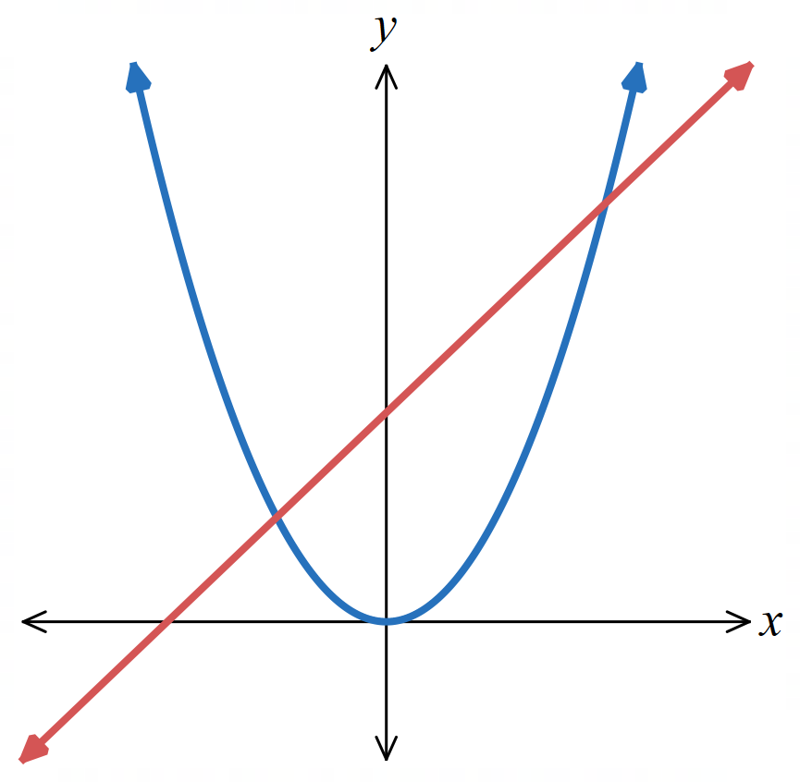
  - Find the area of the region bounded by the parabola $y=x^{2}$ and the line $y=x+2$.

Intersections: $x² = x + 2 ⟹ x = -1, x = 2$.
$$Area = \int_{-1}^{2}{\left(x + 2 - x^{2}\right)}dx = {\left[\frac{x^{2}}{2}+ 2x -\frac{x^{3}}{3}\right]}_{-1}^{2}$$
$$=\frac{10}{3}- \left(-\frac{7}{6}\right)$$
$$=\frac{9}{2}u^{2}$$
  - The area bounded by the curve $y=x²$ and the line $y=x+2$ is rotated about the $x$-axis. Find the exact volume of the solid formed.

Outer radius $= x + 2$, inner radius $= x²:$
$$V = π\int_{-1}^{2}{\left({\left(x + 2\right)}^{2}- x^{4}\right)}dx = π\int_{-1}^{2}{\left(x^{2}+ 4x + 4 - x^{4}\right)}dx$$
$$= π{\left[\frac{x^{3}}{3}+ 2x^{2}+ 4x -\frac{x^{5}}{5}\right]}_{-1}^{2}$$
$$= π\left(\frac{184}{15}- \left(-\frac{32}{15}\right)\right)$$
$$=\frac{72π}{5}u^{3}$$

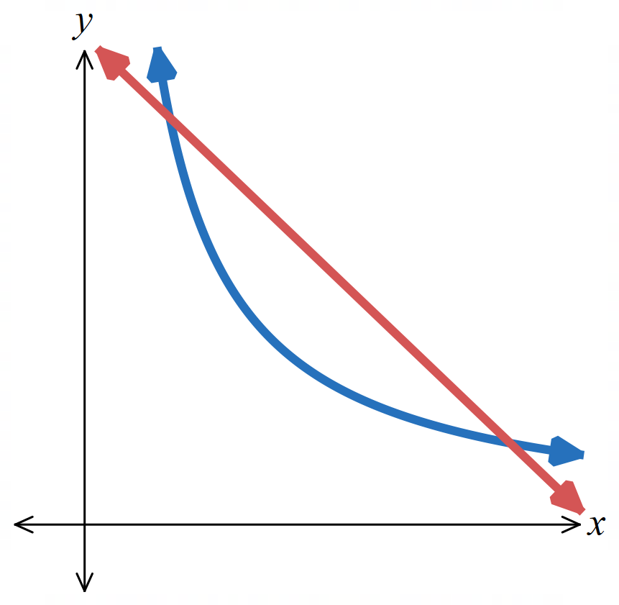
  - The graphs of $xy = 5$ and$x+y=6$ are shown. Find their points of intersection.

Intersections: $xy = 5$ and $x + y = 6$give $x = 1, x = 5.$
  - Find the volume of the solid generated when the region bounded by the two curves is rotated about the $x$-axis.
Outer radius $= 6 - x$, inner radius $=\frac{5}{x}$:
$$V = π\int_{1}^{5}{\left({\left(6 - x\right)}^{2}- 25x^{-2}\right)}dx$$
$$= π{\left[36x - 6x^{2}+\frac{x^{3}}{3}+\frac{25}{x}\right]}_{1}^{5}$$
$$=\frac{64π}{3}u^{3}$$

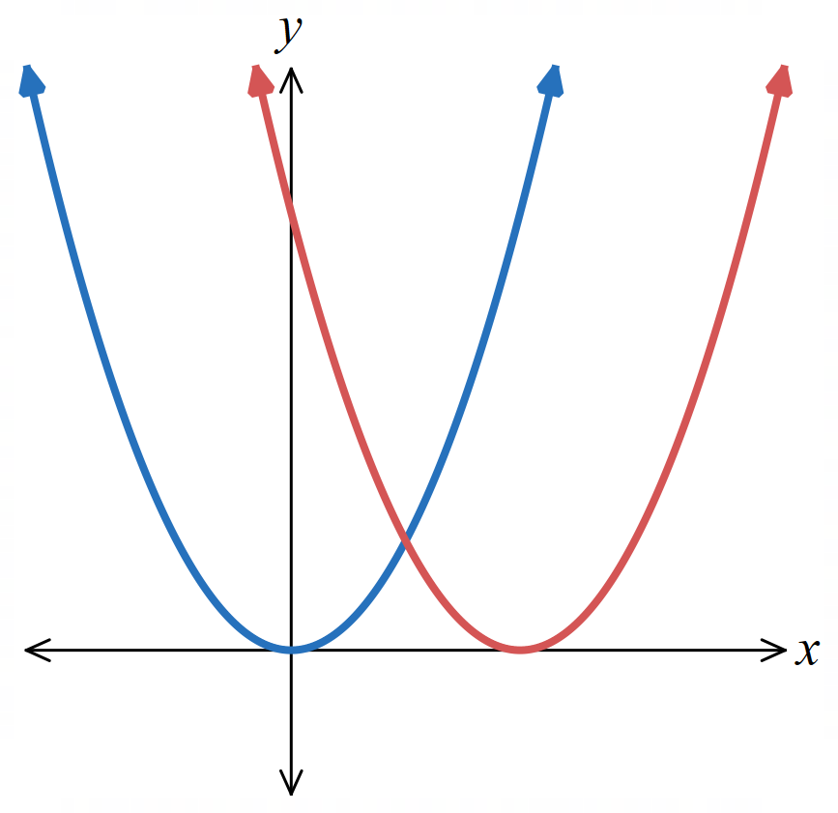
  - Find the area of the region bounded by the functions $y=x², y = {\left(x - 2\right)}^{2}$, and the $x$-axis. Curves intersect at $x=1;y=x²$ meets $x$-axis at $x=0, y=(x-2)²$ meets $x$-axis at $x=2$.

$$Area = \int_{0}^{1}{x^{2}}dx + \int_{1}^{2}{{\left(x - 2\right)}^{2}}dx =\frac{1}{3}+\frac{1}{3}$$
$$=\frac{2}{3}u^{2}$$
  - Find the volume of the solid of revolution formed when the area enclosed between
$y=x², y={\left(x-2\right)}^{2}$, and the $x$-axis is rotated about the $x$-axis.
$$V = π\int_{0}^{1}{x^{4}}dx + π\int_{1}^{2}{{\left(x - 2\right)}^{4}}dx$$
$$=\frac{π}{5}+\frac{π}{5}$$
$$=\frac{2π}{5}u^{3}$$
- The region bounded by the hyperbola $y=2-\frac{2}{x}$, the vertical line $x=1$, and the horizontal line $y = 1$ is rotated about the $x$-axis. Find the volume of the solid formed.
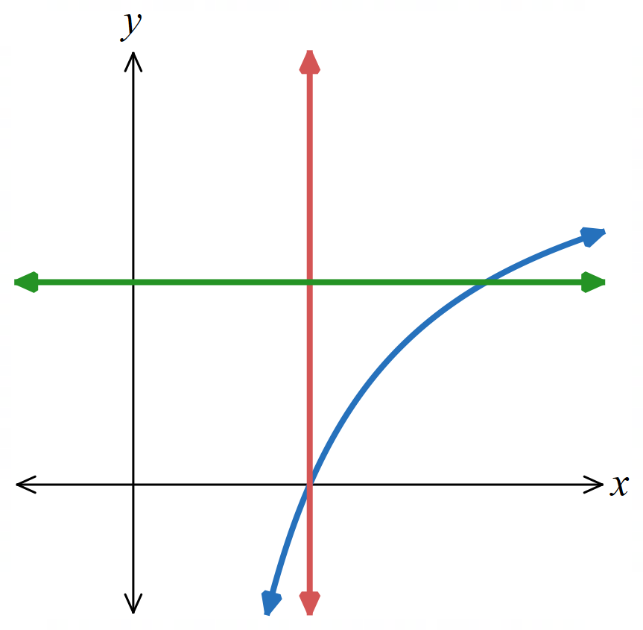
$y = 1$ when $x = 2$; outer radius = 1, inner radius $= 2 -\frac{2}{x}$, $x$ from 1 to 2:
$$V = π\int_{1}^{2}{\left(1 - {\left(2 -\frac{2}{x}\right)}^{2}\right)}dx = π\int_{1}^{2}{\left(-3 +\frac{8}{x}- 4x^{-2}\right)}dx$$
$$= π{\left[-3x + 8 ln x +\frac{4}{x}\right]}_{1}^{2}$$
$$= π\left(8 ln 2 - 5\right) u^{3}$$

Mastery
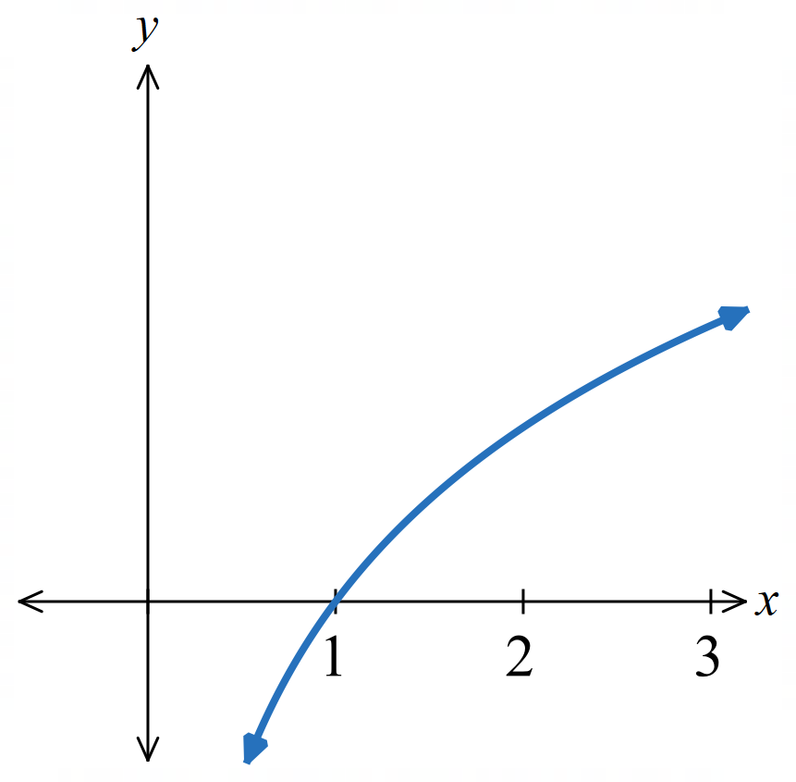
- A rubber washer is generated by rotating the region between the curve $y=log_{e} x$, the $x$-axis, and the line $x=2$ about the $y$-axis. Find the exact volume of the washer.

$x = e^{y}$; outer radius = 2, inner radius = $eʸ$, $y$ from 0 to $ln 2$:
$$V = π\int_{0}^{ln 2}{\left(4 - e^{2y}\right)}dy = π{\left[4y -\frac{e^{2y}}{2}\right]}_{0}^{ln 2}$$
$$= π\left(\left(4 ln 2 - 2\right)- \left(-\frac{1}{2}\right)\right)=\frac{π}{2}\left(8 ln 2 - 3\right)u^{3}$$

  - Find the equation of the tangent to the curve $y = x³+2$ at the point where $x = 1$.
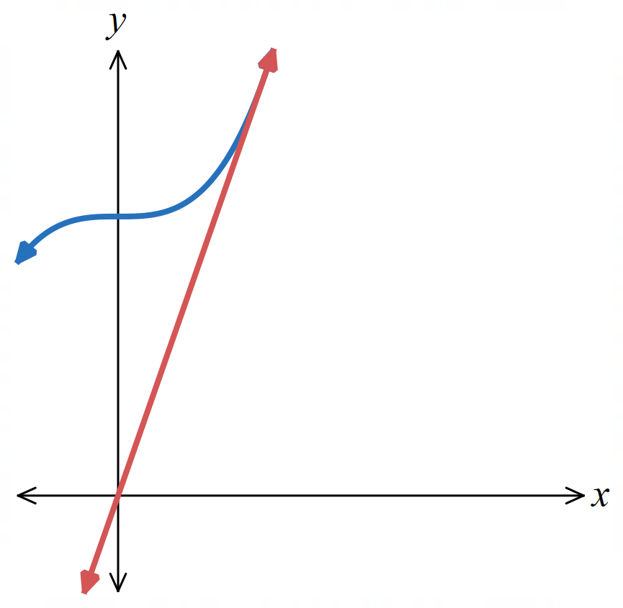
  - Draw a diagram showing the region bounded by the curve, the tangent, and the $y$-axis.

$y' = 3x²$; at $x = 1: y = 3,$ gradient = 3.
Tangent:$y-3 = 3(x-1).$
$$y=3x$$

  - Calculate the volume of the solid formed when this region is rotated about:
- the $x$-axis  Outer radius $x³ + 2$, inner radius $3x, x$ from 0 to 1:  $$V = π\int_{0}^{1}{\left({\left(x^{3}+ 2\right)}^{2}- 9x^{2}\right)}dx$$  $$= π\int_{0}^{1}{\left(x^{6}+ 4x^{3}- 9x^{2}+ 4\right)}dx$$  $$= π{\left[\frac{x^{7}}{7}+ x^{4}- 3x^{3}+ 4x\right]}_{0}^{1}$$  $$=\frac{15π}{7}u^{3}$$ | - the $y$-axis  For $y$ from 0 to 2:  outer radius $=$ $\frac{y}{3}$ (tangent), inner radius = 0 ($y$-axis):  $$V_{1}= π\int_{0}^{2}{{\left(\frac{y}{3}\right)}^{2}}dy = \left(\frac{π}{9}\right){\left[\frac{y^{3}}{3}\right]}_{0}^{2}=\frac{8π}{27}$$  For $y$ from 2 to 3:  outer radius $=\frac{y}{3}$, inner radius = ${\left(y - 2\right)}^{\frac{1}{3}}$  $$V_{2}= π\int_{2}^{3}{\left({\left(\frac{y}{3}\right)}^{2}- {\left(y - 2\right)}^{\frac{2}{3}}\right)}dy$$  $$= π{\left[\frac{y^{3}}{27}- \left(\frac{3}{5}\right){\left(y - 2\right)}^{\frac{5}{3}}\right]}_{2}^{3}$$  $$= π\left(\left(1 -\frac{3}{5}\right)- \left(\frac{8}{27}- 0\right)\right)$$  $$= π\left(\frac{2}{5}-\frac{8}{27}\right)=\frac{14π}{135}$$  $$V =\frac{8π}{27}+\frac{14π}{135}=\frac{2π}{5}u^{3}$$

